Exam AZ-900: Microsoft Azure Fundamentals

Skills measured as of January 23, 2024:

**Audience profile**

As a candidate for this exam, you’re a technology professional who wants to demonstrate foundational knowledge of cloud concepts in general and Microsoft Azure in particular. This exam is a common starting point in a journey towards a career in Azure.

**You can describe Azure architectural components and Azure services, such as:**

* Compute
* Networking
* Storage

**You can also describe features and tools to secure, govern, and administer Azure.**

**You should have skills and experience working with an area of IT, such as:**

* Infrastructure management
* Database management
* Software development

**Skills at a glance:**

* **Describe cloud concepts (25–30%)**
* **Describe Azure architecture and services (35–40%)**
* **Describe Azure management and governance (30–35%)**

Table of Contents

Describe cloud concepts (25–30%) 5

Describe cloud computing. 5

Define cloud computing: 5

Describe the shared responsibility model. 13

Define cloud models, including public, private, and hybrid. 15

Describe the consumption-based model. 20

Compare cloud pricing models. 24

Describe serverless. 27

Describe the benefits of using cloud services. 28

Describe the benefits of high availability and scalability in the cloud. 28

Describe the benefits of reliability and predictability in the cloud. 30

Describe the benefits of security and governance in the cloud. 31

Describe the benefits of manageability in the cloud. 32

Describe cloud service types. 33

Describe infrastructure as a service (IaaS). 33

Describe platform as a service (PaaS). 36

Describe software as a service (SaaS). 37

Identify appropriate use cases for each cloud service type (IaaS, PaaS, and SaaS). 38

Describe Azure architecture and services (35–40%) 41

Describe the core architectural components of Azure. 41

Describe Azure datacenters. 41

Describe Azure regions, region pairs, and sovereign regions. 43

Describe availability zones. 47

Describe Azure resources and resource groups. 56

Describe subscriptions. 63

Describe management groups. 64

Describe the hierarchy of resource groups, subscriptions, and management groups. 65

Describe Azure compute and networking services. 66

Compare compute types, including containers, virtual machines, and functions. 66

Describe virtual machine options, including Azure virtual machines, Azure Virtual Machine Scale Sets, availability sets, and Azure Virtual Desktop. 67

Describe the resources required for virtual machines. 72

Describe application hosting options, including web apps, containers, and virtual machines. 74

Describe virtual networking, including the purpose of Azure virtual networks, Azure virtual subnets, peering, Azure DNS, Azure VPN Gateway, and ExpressRoute. 84

Define public and private endpoints. 96

Describe Azure storage services. 98

Compare Azure Storage services. 98

Describe redundancy options. 103

Describe storage tiers. 110

Describe migration options, including Azure Migrate and Azure Data Box. 117

Identify options for moving files, including AzCopy, Azure Storage Explorer, and Azure File Sync. 119

Describe Azure identity, access, and security. 120

Describe authentication methods in Azure, including single sign-on (SSO), multi-factor authentication (MFA), and passwordless. 128

Describe external identities in Azure, including business-to-business (B2B) and business-to-customer (B2C) 132

Describe Microsoft Entra Conditional Access. 134

Describe Azure role-based access control (RBAC). 136

Describe the concept of Zero Trust. 143

Describe the purpose of the defense-in-depth model. 145

Describe the purpose of Microsoft Defender for Cloud. 148

Describe Azure management and governance (30–35%) 154

Describe Azure management and governance. 154

Describe factors that can affect costs in Azure. 154

Compare the pricing calculator and the Total Cost of Ownership (TCO) Calculator. 162

Describe cost management capabilities in Azure. 184

Describe the purpose of tags. 192

Describe features and tools in Azure for governance and compliance. 197

Describe the purpose of Microsoft Purview in Azure. 197

Describe the purpose of Azure Policy. 199

Describe the purpose of resource locks. 205

Describe features and tools for managing and deploying Azure resources. 210

Describe the Azure portal. 210

Describe Azure Cloud Shell, including Azure Command-Line Interface (CLI) and Azure PowerShell 211

Describe the purpose of Azure Arc. 215

Describe Azure Resource Manager (ARM) and ARM templates. 216

Describe infrastructure as code (IaC). 217

Describe monitoring tools in Azure. 219

Describe the purpose of Azure Advisor. 219

Describe Azure Service Health. 222

Describe Azure Monitor, including Log Analytics, Azure Monitor alerts, and Application Insights. 224

Extra Topics. 226

Azure Load Balancer. 226

Application Gateway. 228

Content Delivery Network (CDN). 229

Database Services. 231

Azure Cosmos DB. 231

Azure SQL Database. 233

Azure SQL. 234

Azure Marketplace. 235

Azure IoT (Internet of Things). 236

Azure Sphere. 238

Big Data Services. 239

Azure Synapse Analytics. 240

Azure HDInsight. 241

Azure Databricks. 242

Artificial Intelligence Services. 244

Serverless Computing. 247

Azure Functions. 247

Azure Logic Apps. 248

Event Grid. 250

Azure DevOps and Azure DevTest Labs. 252

Describe securing network connectivity in Azure: 255

Network Security Group (NSG). 255

Application Security Groups (ASG). 257

User Defined Routes (UDR). 260

Azure Firewall. 262

Azure DDoS Attack. 264

Azure Key Vault. 266

Azure Blueprint. 268

Cloud Adoption Framework: 274

Describe privacy and compliance resources. 285

Microsoft Privacy Statement. 285

Online Services Terms (OST). 286

Data Protection Addendum. 287

Azure Compliance Docs. 291

Describe Azure cost management and Service Level Agreements (10-15%): 292

Azure SLAs. 292

Service Credit. 293

Composite SLAs. 294

Service Life Cycle in Azure. 298

# Describe cloud concepts (25–30%)

## Describe cloud computing.

### Define cloud computing:

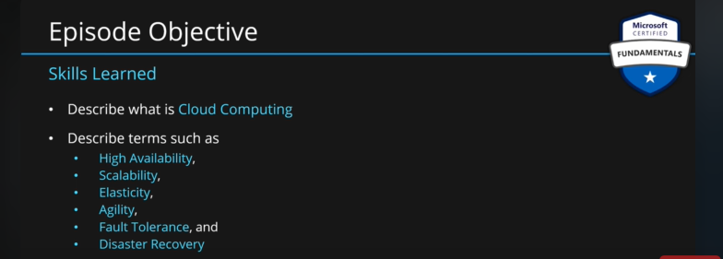

**Cloud Computing:** It is a delivery model for services.

If you want to **store data** on the cloud Azure provides you with popular DBs and the tools to migrate data to the cloud.

To use this data to any meaningful work, we need **computation**. Cloud provides computer power which we can use to work on the data. Cloud allows us to create applications. These can be web apps, AI, machine learning or reporting etc.

Once we have components of our app ready, we also need to connect them securely. Cloud allows us to create **secure** **networks** between our components.

Since our app is in the cloud, cloud also provides **analytics capabilities** which helps us to get the performance and telemetry data of our app.

These are four main services provided by cloud. Cloud provides many services apart from these as well. But these are the services which are tested by the exam.

All these services are provided through the internet. Providing these services over the internet does not make a cloud. Cloud needs to fulfill certain characteristics as well.

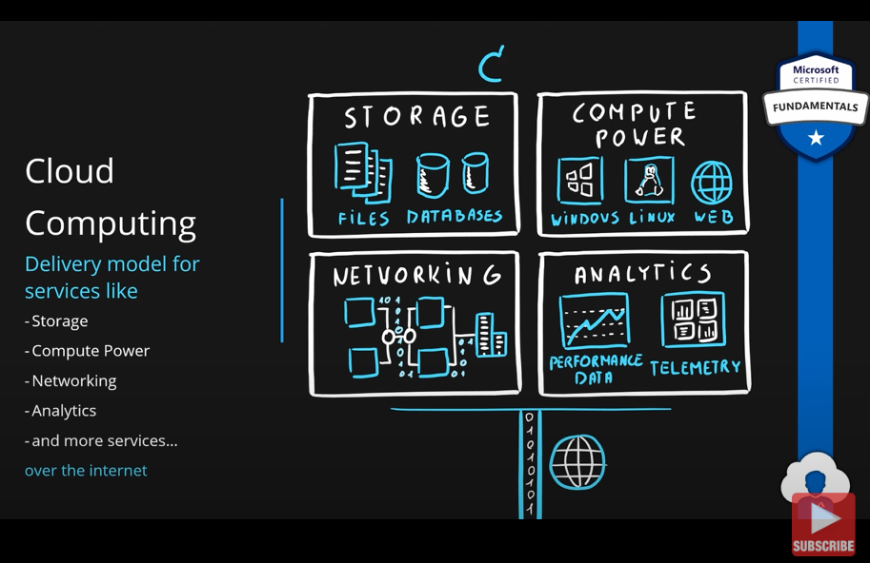

**Key Characteristics:**

**Scalability:** Cloud can provide many resources such as server, DB, virtual machine etc. Scalability refers to the ability to increase or decrease the resources.

If we increase the size of the resource by adding more RAM, CPU or Disk etc., we are moving in the vertical direction, and this is called **vertical scaling**. Increasing the size of the resource is called **scaling up** and decreasing the size of the resource is called **scaling down**.

We can also scale by adding more resources or by increasing the number of resources. We are moving along the horizontal direction; this is called **horizontal scaling**. Increasing the number of resources is called **scaling out**, decreasing the number of resources is called **scaling in**.

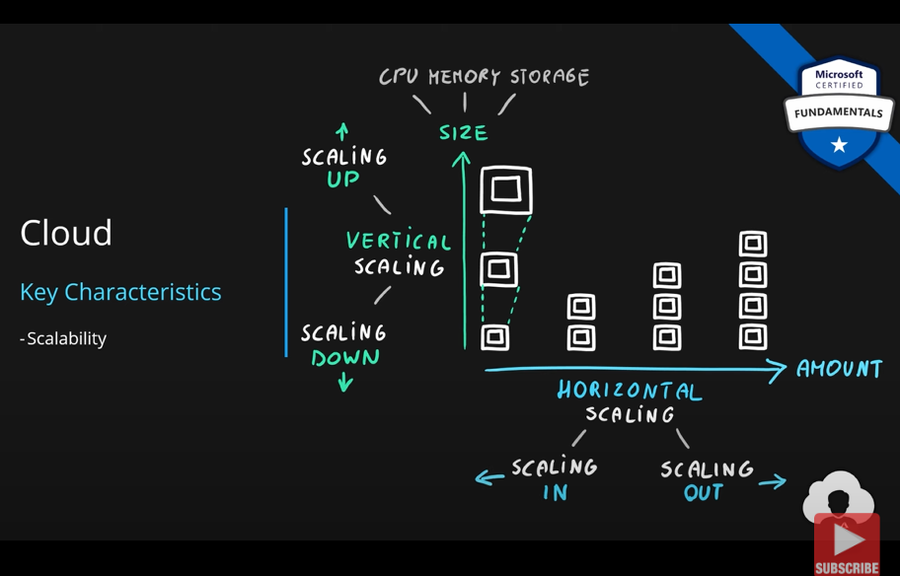

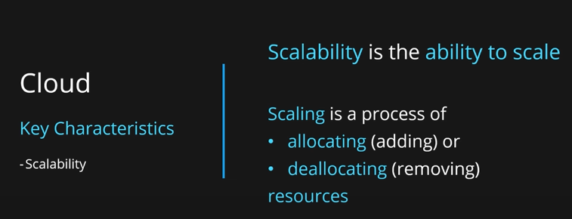

**Elasticity:** Our resources will not face the same load throughout the day or throughout a specific period of time. The load can increase of decrease. Cloud should be able to allocate of deallocate the resources depending upon the load ie, cloud should be able to **scale automatically** based on the load. This is called **elasticity**.

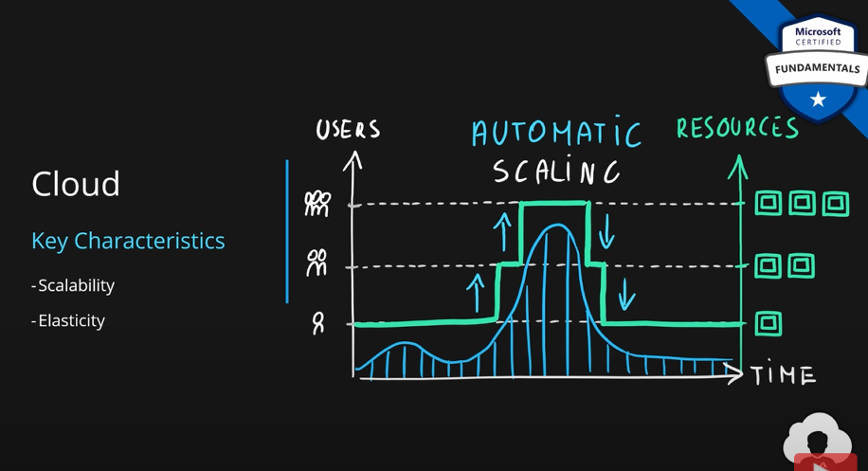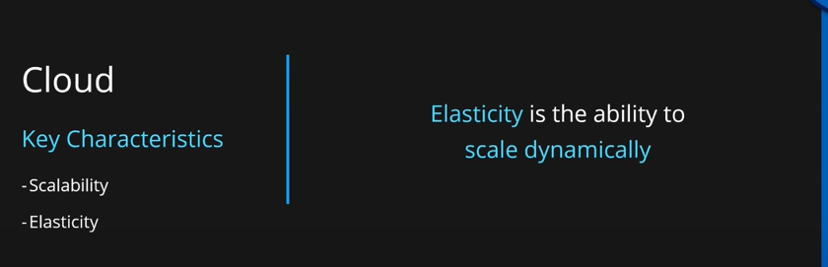

**Agility:** We can allocate resources manually using a portal or automated ways using scripting. In both cases, we submit a request of the resource, and we get a response. The time taken between the two is what determines the agility of the cloud.

When we have on premise resources, this time can be days, weeks or months. In cloud, it is second, minutes or for very big services, hours.

Agility is the ability of the cloud to allocate or deallocate resources in very short period of time.

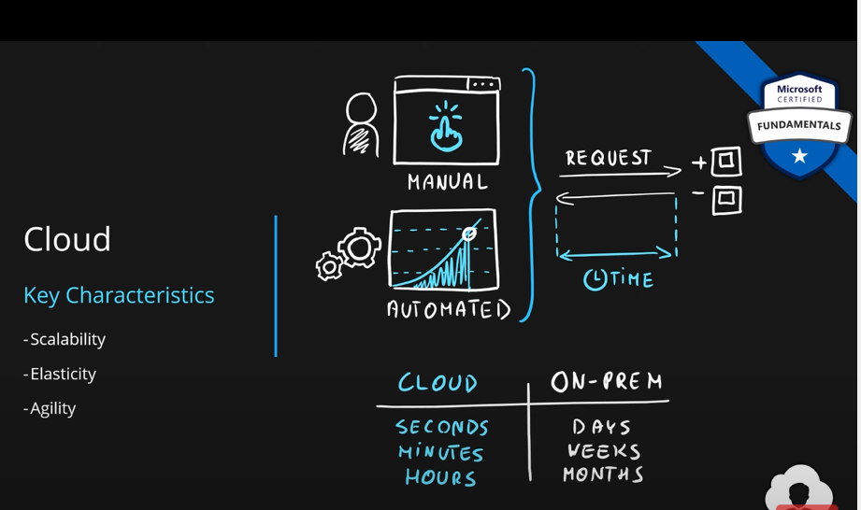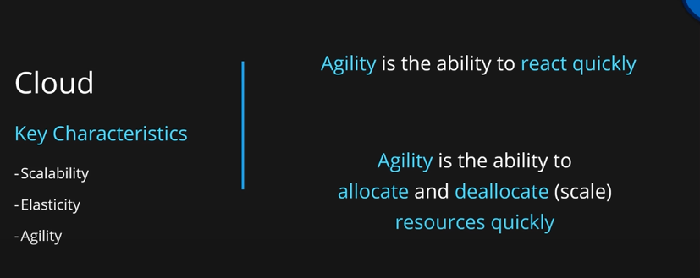

**Fault Tolerance:** As users, we use various services provided by the cloud such as web server, VM, DBs etc. These services must run in some data centers. Data may be stored in disk or disk arrays. Whenever there is a component or server failure on these data centers, our service is automatically moved onto another server. Same goes for data. Data is stored on multiple disks and disk arrays. If one fails, others will be used to recover.

Clouds are configured for **fault tolerance**. If something fails in the data center, we as users will not know notice the failures.

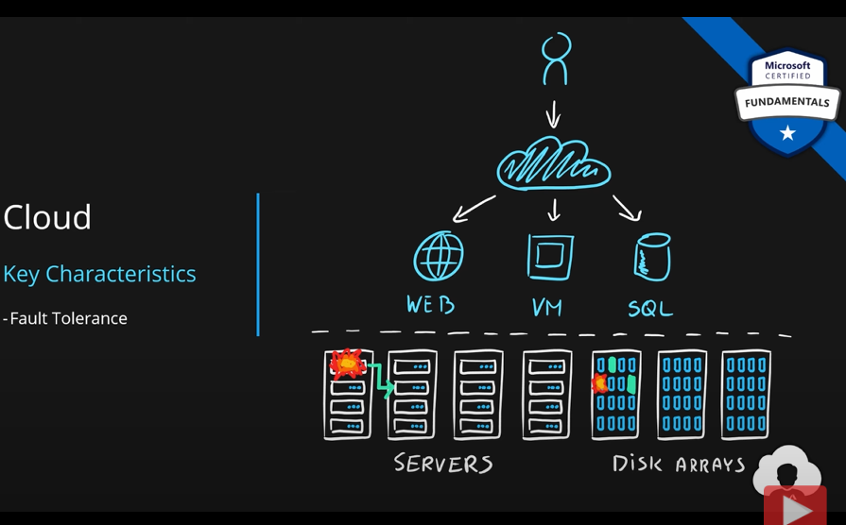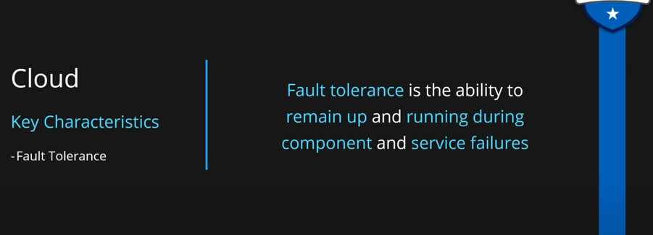

If the failure is too big then it is called **disaster.** They include floods, earthquakes, thunderstorms, power grid failures etc. They also include human errors. They can affect entire Azure data center or service.

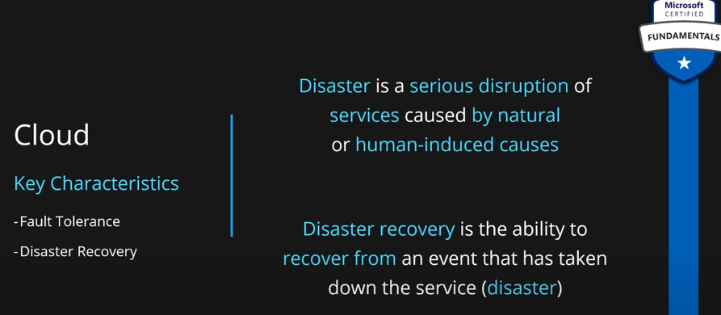

**Disaster recovery** means keeping two copies of the same application in two azure regions. Replication is set up between them so, we have two identical copies of the same application. DNS is set up in front of the application. The user is sent to the working version of the application if one of the versions fail.

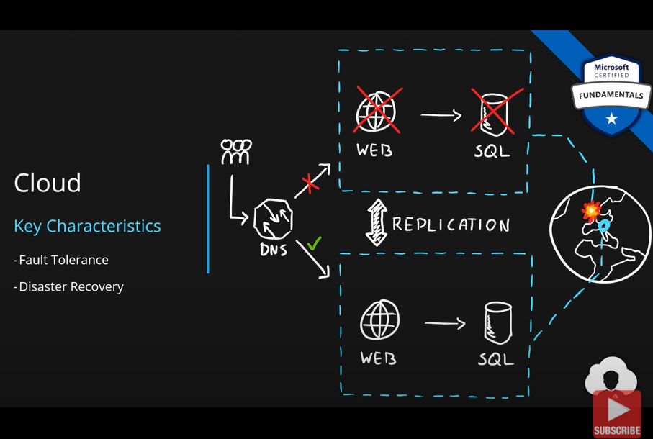

**Availability:** This simply the metrics which measure the **uptime** of the service ie, for how much time the service was available for the users or other services vs the **downtime** which is the time for which the service was not available. Downtime can be because of planned occurrences such as for patching or unplanned system failures.

**Availability = uptime / total time of the service = uptime / uptime + downtime**

**Availability** can be measured for a year, a month or for a day. Most companies will go till four nines ie, 99.99% availability.

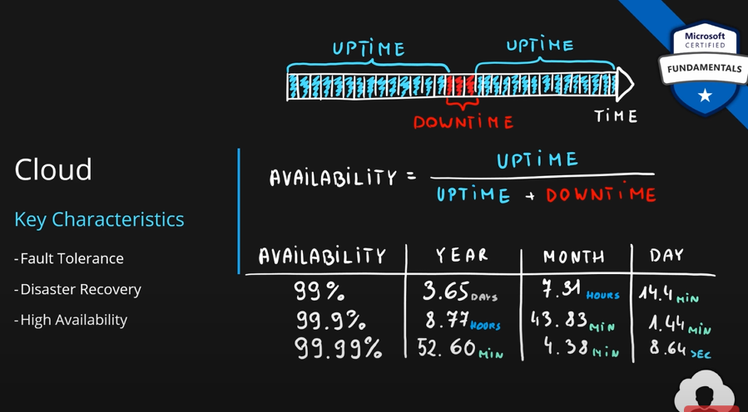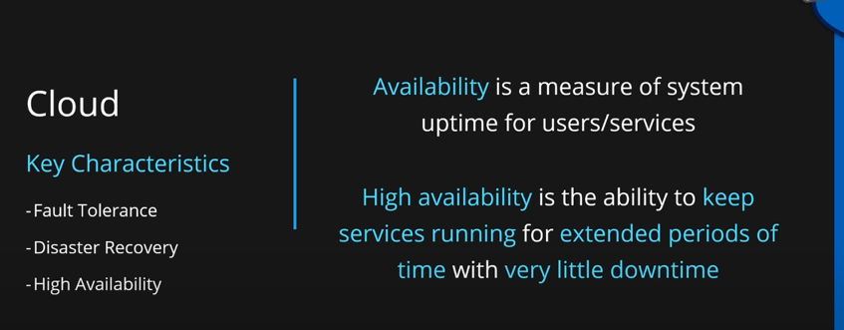

Based on the requirements we need to choose the time at which this system should be highly available.

In Azure many services deliver very high availability.

### Describe the shared responsibility model.

You may have heard of the shared responsibility model, but you may not understand what it means or how it impacts cloud computing.

Start with a traditional corporate datacenter. The company is responsible for maintaining the physical space, ensuring security, and maintaining or replacing the servers if anything happens. The IT department is responsible for maintaining all the infrastructure and software needed to keep the datacenter up and running. They’re also likely to be responsible for keeping all systems patched and on the correct version.

With the shared responsibility model, these responsibilities get shared between the cloud provider and the consumer. Physical security, power, cooling, and network connectivity are the responsibility of the cloud provider. The consumer isn’t collocated with the datacenter, so it wouldn’t make sense for the consumer to have any of those responsibilities.

At the same time, the consumer is responsible for the data and information stored in the cloud. (You wouldn’t want the cloud provider to be able to read your information.) The consumer is also responsible for access security, meaning you only give access to those who need it.

Then, for some things, the responsibility depends on the situation. If you’re using a cloud SQL database, the cloud provider would be responsible for maintaining the actual database. However, you’re still responsible for the data that gets ingested into the database. If you deployed a virtual machine and installed an SQL database on it, you’d be responsible for database patches and updates, as well as maintaining the data and information stored in the database.

With an on-premises datacenter, you’re responsible for everything. With cloud computing, those responsibilities shift. The shared responsibility model is heavily tied into the cloud service types (covered later in this learning path): infrastructure as a service (IaaS), platform as a service (PaaS), and software as a service (SaaS). IaaS places the most responsibility on the consumer, with the cloud provider being responsible for the basics of physical security, power, and connectivity. On the other end of the spectrum, SaaS places most of the responsibility with the cloud provider. PaaS, being a middle ground between IaaS and SaaS, rests somewhere in the middle and evenly distributes responsibility between the cloud provider and the consumer.

The following diagram highlights how the Shared Responsibility Model informs who is responsible for what, depending on the cloud service type.

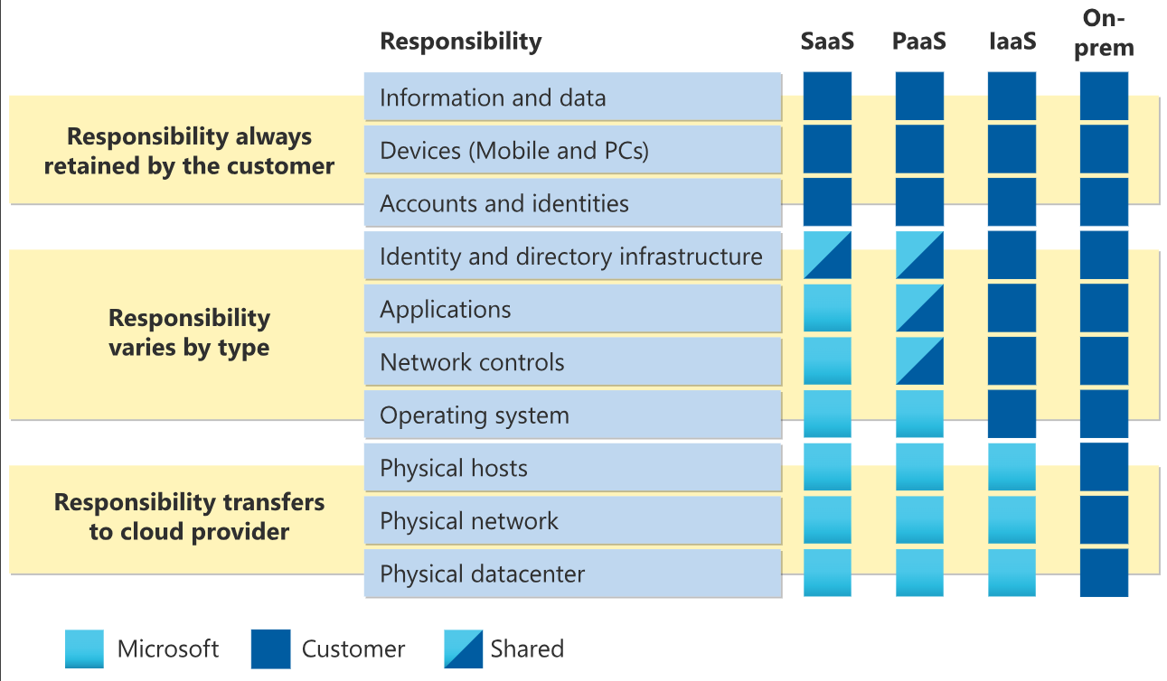

**You’ll always be responsible for:**

* The information and data stored in the cloud.
* Devices that are allowed to connect to your cloud (cell phones, computers, and so on)
* The accounts and identities of the people, services, and devices within your organization

**The cloud provider is always responsible for:**

* The physical datacenter
* The physical network
* The physical hosts

**Your service model will determine responsibility for things like:**

* Operating systems
* Network controls
* Applications
* Identity and infrastructure

### Define cloud models, including public, private, and hybrid.

Cloud Deployment Model is simple a separation which describes where are the company resources deployed. Whenever this is in public cloud provider environment or private datacenter.

**Public, Private and Hybrid Cloud:**

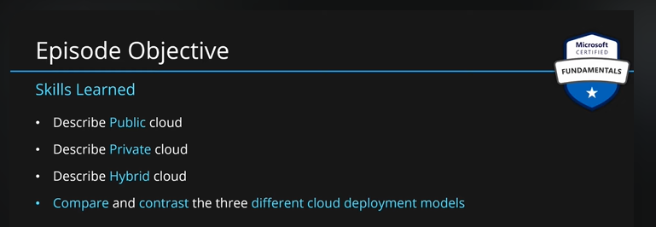

**Public Cloud:** We can either deploy our app on our own datacenters or on the cloud service provider’s data center. If we choose to do the latter, it is called **public cloud.**

We will not have our own hardware at all. Everything will run on MS’s hardware. Also, sometimes the same hardware’s are also shared with other customers as well.

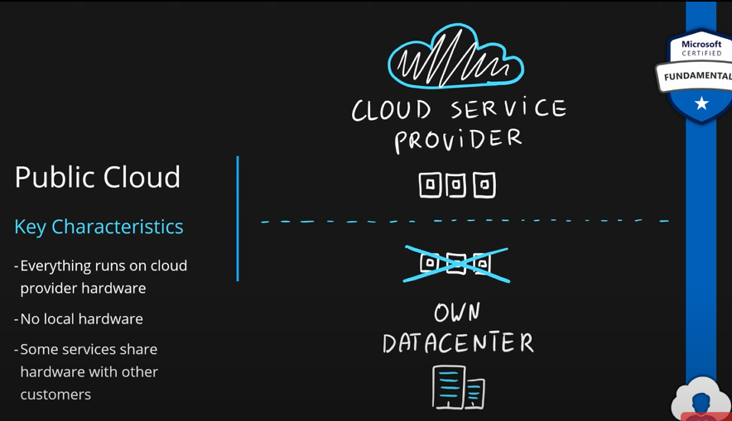

**Advantages:**

1. No **CapEx**; no big investments need from our side.
2. We get **high availability and agility** of the cloud.
3. Only pay for the resource you use.
4. No hardware maintenance.
5. No deep technical skills required to set up hardware, servers etc.

**Disadvantages:**

1. The public cloud may **not be able to meet some government policies, industry standards or legal requirements,** the public cloud may not be able to meet.
2. Since MS owns the hardware, you cannot **make changes to the hardware** if you wish to do so.
3. If you have some **specific or unique business requirements,** public cloud may not be able to provide that.

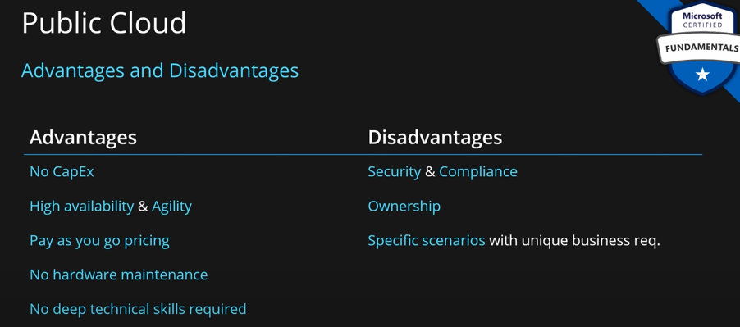

**Private Cloud:** It is the opposite of the public cloud. Everything runs on your own datacenter. You need to provide all the cloud services to yourself. You have to maintain all the hardware by yourself.

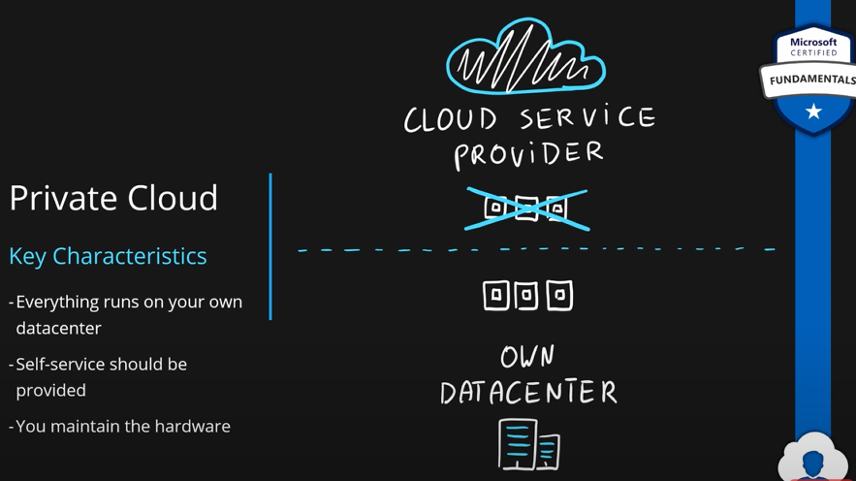

**Advantages:**

1. Since you own the hardware, you can support any scenario. You can make changes to the hardware as you wish.
2. You have full control over the security. With this, you will **be able to meet any government policies, industry standards or legal requirements.**

**Disadvantages:**

1. Requires **huge initial capital** for the set up.
2. Not easy to scale up or down. Hence, **limited agility.**
3. You team needs to **have skills and expertise** to set up the cloud and maintain it.

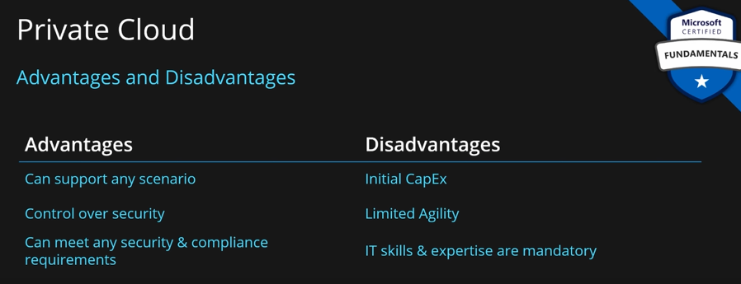

**Hybrid Cloud:** You combine public and private clouds together to create the greatest flexibility.

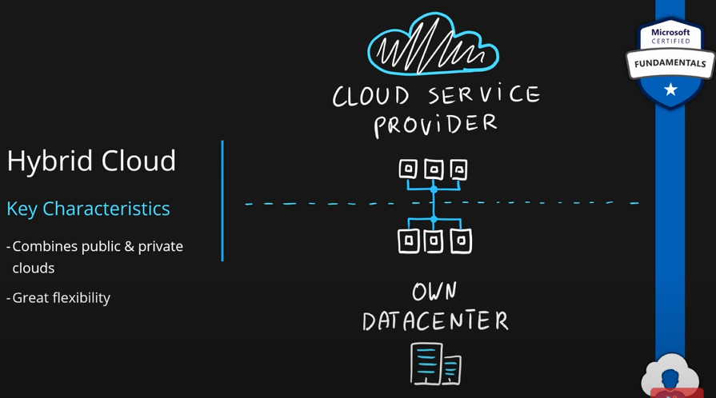

**Advantages:**

1. Great flexibility.
2. Run legacy apps in private cloud.
3. Utilize existing infrastructure if you already have that.
4. Meet any security requirements.
5. take advantage of all public cloud benefits.

**Basically you take advantage of both public and private cloud models.**

**Disadvantages:**

1. Bigger env with both public and private clouds can be expensive.
2. Hard to manage.
3. IT skills are required.

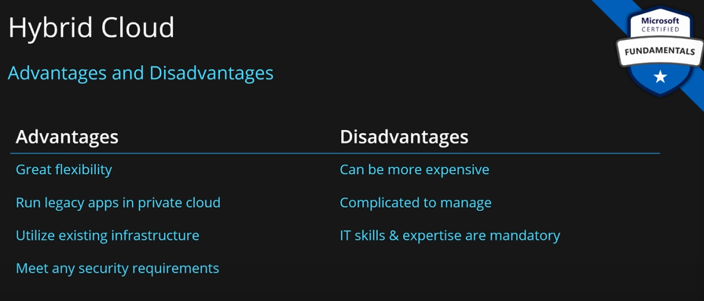

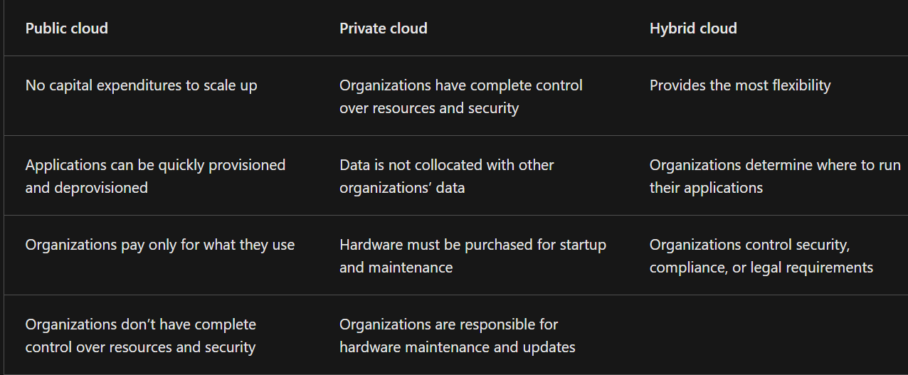

**Multi-cloud**

A fourth, and increasingly likely scenario is a multi-cloud scenario. In a multi-cloud scenario, you use multiple public cloud providers. Maybe you use different features from different cloud providers. Or maybe you started your cloud journey with one provider and are in the process of migrating to a different provider. Regardless, in a multi-cloud environment you deal with two (or more) public cloud providers and manage resources and security in both environments.

**Azure Arc**

Azure Arc is a set of technologies that helps manage your cloud environment. Azure Arc can help manage your cloud environment, whether it’s a public cloud solely on Azure, a private cloud in your datacenter, a hybrid configuration, or even a multi-cloud environment running on multiple cloud providers at once.

**Azure VMware Solution**

What if you’re already established with VMware in a private cloud environment but want to migrate to a public or hybrid cloud? Azure VMware Solution lets you run your VMware workloads in Azure with seamless integration and scalability.

### Describe the consumption-based model.

**Economy of scale:** If we have a new/small business and we buy things for our business, it will cost a certain amount. This cost can be reduced if we have a bigger business. This is because with bigger business, we will be able to buy things in bulk and in bulk the things will cost us less.

The money we save can be used to make the product better and get more profit.

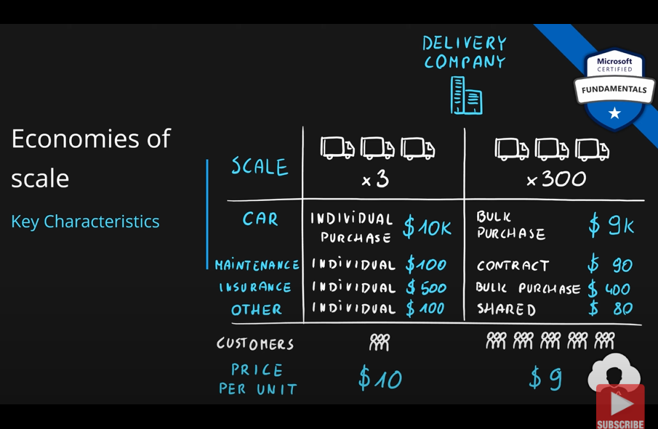

So, as the company grows, the cost per unit of the company goes down.

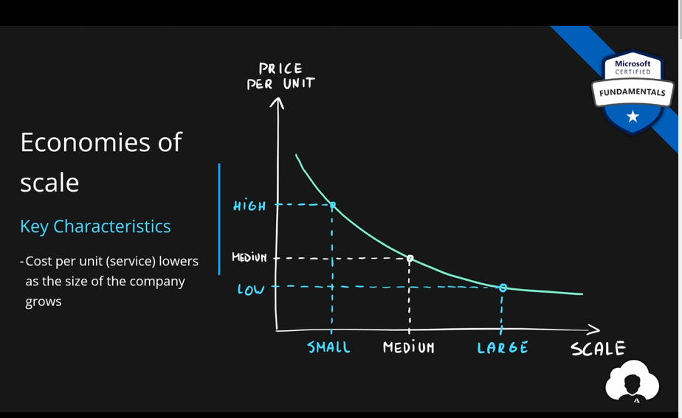

Same concept is happening with the cloud. Cloud companies such as MS have many customers and bigger business. Due to that they are able to make data centers with lower costs because they get better deals from other venders due to larger orders. They are able to get things such as RAMs, CPUs, Disks, real estate etc. for lower prices due to larger orders. This is how azure provides services at cheaper prices.

**Capital Expenditure (CapEx) and Operational Expenditure (OpEx)**:

Expenditure is basically how you spend money. How this spending of money differs when you buy servers from the cloud vs when you buy on-premises servers.

**CapEx** means buying your own infrastructure. This has high initial cost. There is low maintenance cost after the initial investment. Here server capacity is fixed to whatever size you buy. Initially your app is smaller, so, the capacity of the server is wasted. As time passes, app grows and exceeds your server capacity. Now, you have to buy a bigger server.

Also, you have to maintain these servers. Which will cost you.

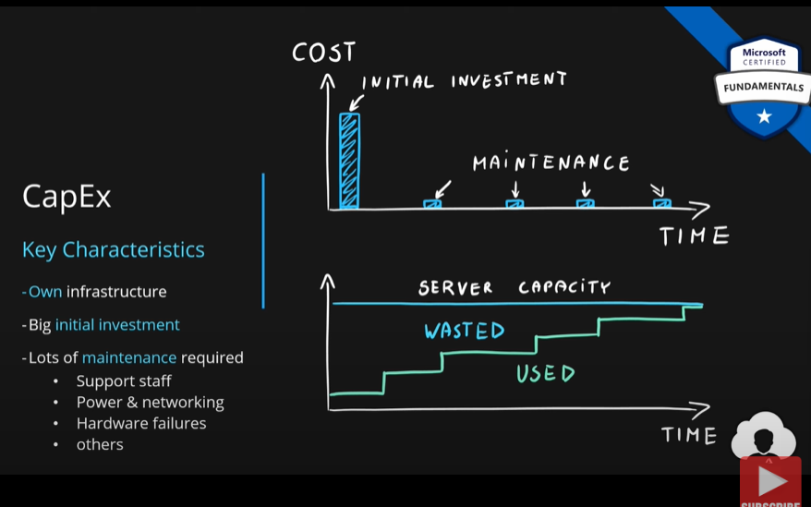

**Operational Expenditure (OpEx)** means instead of buying you rent servers. Cloud fits here. There is no initial investment. You pay for whatever you use. Also, no maintenance is needed. Cloud will manage the server for you. Some small maintenance is needed from your end.

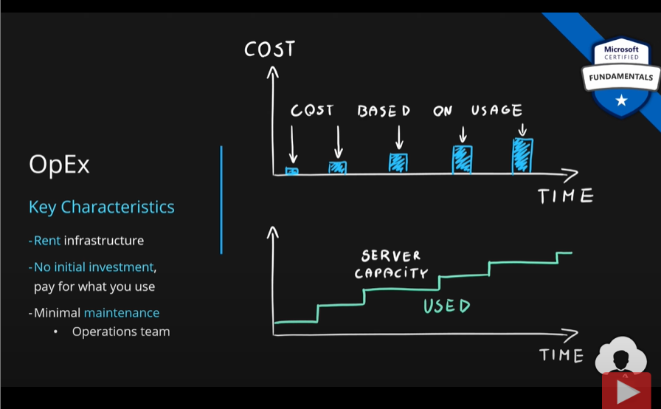

Comparison:

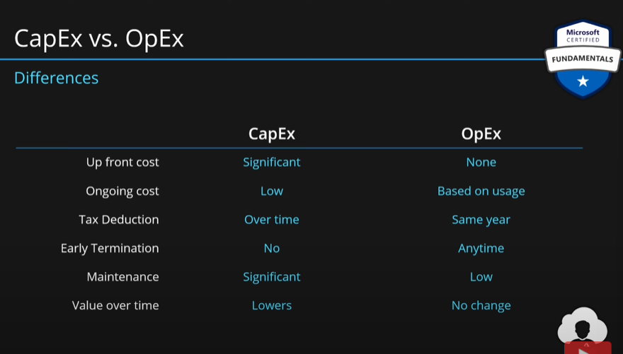

**Consumption Based Model:** Load on services is never constant. It fluctuates over time. We want to allocate more resources when demand increases and deallocate resources when the demand drops. Since cloud is elastic, we don’t need to allocate and deallocate resources manually. This happens automatically. Also, we only want to pay for the resources which we used. With **Consumption Based Model,** we only pay for the resources we used. If we use more, we pay more and vice versa.

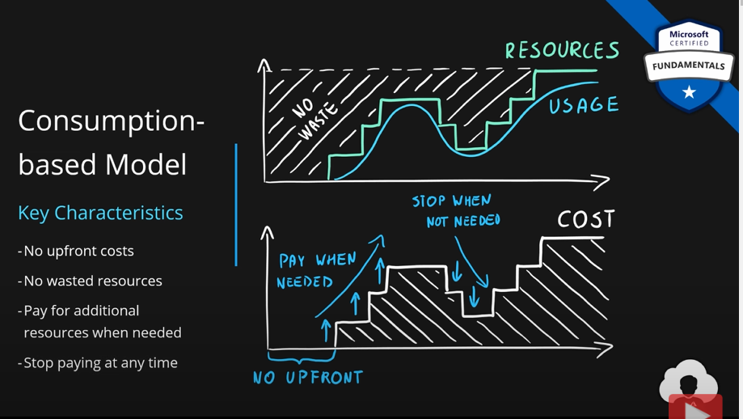

Eg. MS charges for their virtual machines based on certain parameters/metrics. These are **compute power ie CPU, storage ie disk space, network.** So, you the user is charged for your virtual machine based on how much compute power your machine has, how much storage space you have been provided and how networking is set up. Also, you will be charged only for the amount of time you used the services.

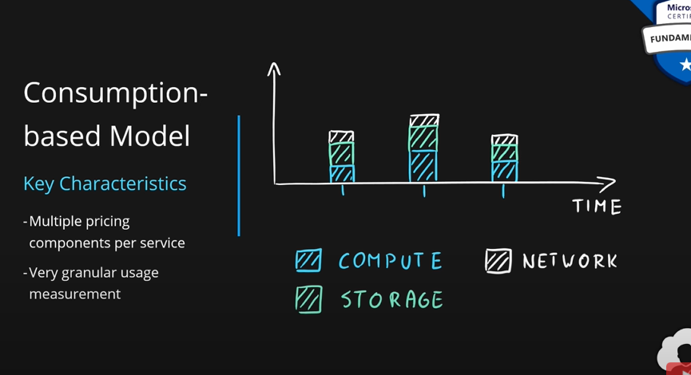

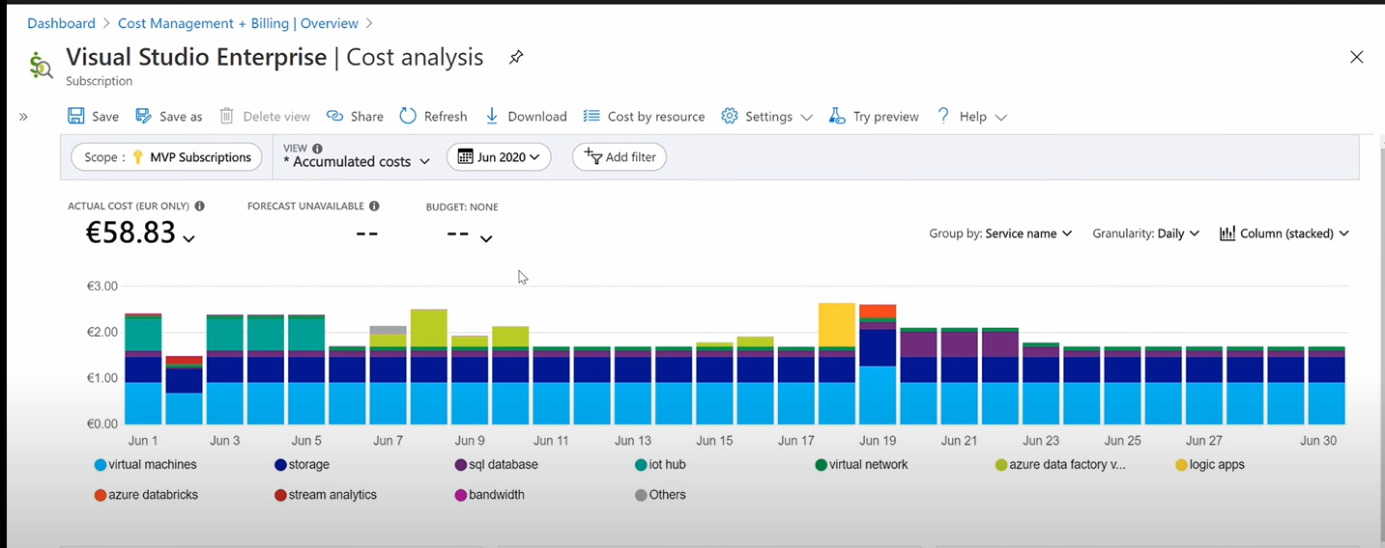

### Compare cloud pricing models.

This blog post explains the major differences between **On-demand, Reserved VM Instances and Dedicated Hosts.**

**Why compare cloud pricing models?**

The right cloud pricing model for your business depends on a number of factors. You’ll need to decide whether you’re going to use demand-based pricing, reserved or dedicated models, as well as how many volumes of data you want to store in the cloud and what type of security measures are important for your applications.

Here’s how different types of cloud pricing models work:

**What is pay as you go (PAYG)?**

Pay as you go (PAYG) is a pricing model that charges customers for what they use. This means that tHere’s no upfront commitment or upfront payment required, and you pay only for the resources you use.

Pay as you go works best when it allows users to get started with your product quickly, but it can also be used as a way to limit usage if necessary—for example, if someone starts using too much bandwidth or storage space in their account.

**On-demand pricing vs. reserved pricing**

On-demand pricing is the most common way of charging for cloud services. The term “on-demand” refers to the fact that you pay only for what you use, when you need it, and how much capacity is needed. For example:

If 100GB of storage is needed for an Azure VM lasting a month, then on-demand pricing would charge $0.02 per GB per month (assuming 30 days).

If a compute instance runs for 24 hours at peak times but only uses 5% CPU resources, then this would still be considered “on demand” and thus not subject to any additional charge beyond what was originally paid at time of purchase (e.g., if someone buys 20MB RAM on their credit card with $500 monthly spend limit—at $5/mo/MB purchased) they could run until they reach their cap without incurring any penalty charges or fees by using offsite backups instead!

**Azure availability sets and upgrade domains**

Azure Availability Sets and Upgrade Domains are the two main option for cloud computing. Both of these options allow you to configure your environment with multiple nodes, which can be used in different scenarios.

Azure’s availability sets allow you to create virtual machines (VMs) across multiple locations within an Azure region. You can also have one or more VMs running at any time on a specific node within an availability set; this is known as a “cross-region” deployment scenario, because it allows you to separate applications into different regions and keep them up to date at all times by replicating their data between the different regions in real time.

An upgrade domain allows customers who want more control over their deployments than they would get from Azure SQL Database Standard Edition but don’t need all the bells and whistles found in Enterprise SKUs such as Redis Cache/Memcached/Cassandra etc.

**Reserved virtual machine instances.**

Reserved virtual machine instances are a great option for predictable workloads. You can reserve capacity in the cloud and pay only for what you use, rather than paying for the capacity at any point during the month. Reserved VM Instances generally cost more than on-demand pricing, but they’re more cost effective when your application or workload has predictable usage patterns.

**Summary of the major differences among PAYG, Reserved VM Instances and Dedicated Hosts**

PAYG is the most flexible model, but it’s also the least secure.

On-demand instances are less flexible than reserved instances and dedicated hosts, but they’re more expensive.

Reserved VM Instances provide a good balance between flexibility and price—but they may not suit all workloads perfectly.

Dedicated Hosts are very cost effective for high performance workloads like databases or web servers; however, they require significant upfront capital investment to purchase.

**How to understand on-demand, RI, and DH pricing models.**

There are three main types of cloud pricing models: on-demand, reserved instances and dedicated hosts.

On-demand pricing is the most common model used by enterprises today. This means that you pay for usage based on how much time your instance runs for in a billing period (usually a month). For example, if an application runs for 12 hours per day during peak capacity hours, then it would be charged at 1/12th rate during those times.

Reserved instances are similar to on-demand but they allow companies to reserve capacity ahead of time so that they can plan their workloads around it rather than paying upfront costs upfront like with other types of cloud providers such as Amazon Web Services (AWS) or Microsoft Azure

**Conclusion**

We hope this article has been helpful in understanding the different pricing models for cloud services from a business perspective. Now that you know how to compare these models and which one is best for your company, it’s time to find out what options are available for your organization.

### Describe serverless.

Serverless computing enables developers to build applications faster by eliminating the need for them to manage infrastructure. With serverless applications, the cloud service provider automatically provisions, scales, and manages the infrastructure required to run the code.

In understanding the definition of serverless computing, it’s important to note that servers are still running the code. The serverless name comes from the fact that the tasks associated with infrastructure provisioning and management are invisible to the developer. This approach enables developers to increase their focus on the business logic and deliver more value to the core of the business. Serverless computing helps teams increase their productivity and bring products to market faster, and it allows organizations to better optimize resources and stay focused on innovation.

**Top benefits of serverless computing**

**No infrastructure management**

Using fully managed services enables developers to avoid administrative tasks and focus on core business logic. With a serverless platform, you simply deploy your code, and it runs with high availability.

**Dynamic scalability**

With serverless computing, the infrastructure dynamically scales up and down within seconds to match the demands of any workload.

**Faster time to market**

Serverless applications reduce the operations dependencies on each development cycle, increasing development teams’ agility to deliver more functionality in less time.

**More efficient use of resources**

Shifting to serverless technologies helps organizations reduce TCO and reallocate resources to accelerate the pace of innovation.

## Describe the benefits of using cloud services.

### Describe the benefits of high availability and scalability in the cloud.

**Scalability:** Cloud can provide many resources such as server, DB, virtual machine etc. Scalability refers to the ability to increase or decrease the resources.

If we increase the size of the resource by adding more RAM, CPU or Disk etc., we are moving in the vertical direction, and this is called **vertical scaling**. Increasing the size of the resource is called **scaling up** and decreasing the size of the resource is called **scaling down**.

We can also scale by adding more resources or by increasing the number of resources. We are moving along the horizontal direction; this is called **horizontal scaling**. Increasing the number of resources is called **scaling out**, decreasing the number of resources is called **scaling in**.





**Availability:** This simply the metrics which measure the **uptime** of the service ie, for how much time the service was available for the users or other services vs the **downtime** which is the time for which the service was not available. Downtime can be because of planned occurrences such as for patching or unplanned system failures.

**Availability = uptime / total time of the service = uptime / uptime + downtime**

**Availability** can be measured for a year, a month or for a day. Most companies will go till four nines ie, 99.99% availability.



Based on the requirements we need to choose the time at which this system should be highly available.

In Azure many services deliver very high availability.

### Describe the benefits of reliability and predictability in the cloud.

**Reliability**

Reliability is the ability of a system to recover from failures and continue to function. It’s also one of the pillars of the Microsoft Azure Well-Architected Framework.

The cloud, by virtue of its decentralized design, naturally supports a reliable and resilient infrastructure. With a decentralized design, the cloud enables you to have resources deployed in regions around the world. With this global scale, even if one region has a catastrophic event other regions are still up and running. You can design your applications to automatically take advantage of this increased reliability. In some cases, your cloud environment itself will automatically shift to a different region for you, with no action needed on your part. You’ll learn more about how Azure leverages global scale to provide reliability later in this series.

**Predictability**

Predictability in the cloud lets you move forward with confidence. Predictability can be focused on performance predictability or cost predictability. Both performance and cost predictability are heavily influenced by the Microsoft Azure Well-Architected Framework. Deploy a solution that’s built around this framework, and you have a solution whose cost and performance are predictable.

* **Performance Predictability**

Performance predictability focuses on predicting the resources needed to deliver a positive experience for your customers. Autoscaling, load balancing, and high availability are just some of the cloud concepts that support performance predictability. If you suddenly need more resources, autoscaling can deploy additional resources to meet the demand, and then scale back when the demand drops. Or if the traffic is heavily focused on one area, load balancing will help redirect some of the overload to less stressed areas.

* **Cost Predictability**

Cost predictability is focused on predicting or forecasting the cost of the cloud spend. With the cloud, you can track your resource use in real time, monitor resources to ensure that you’re using them in the most efficient way, and apply data analytics to find patterns and trends that help better plan resource deployments. By operating in the cloud and using cloud analytics and information, you can predict future costs and adjust your resources as needed. You can even use tools like the Total Cost of Ownership (TCO) or Pricing Calculator to get an estimate of potential cloud spend.

### Describe the benefits of security and governance in the cloud.

Whether you’re deploying infrastructure as a service or software as a service, cloud features support governance and compliance. Things like set templates help ensure that all your deployed resources meet corporate standards and government regulatory requirements. Plus, you can update all your deployed resources to new standards as standards change. Cloud-based auditing helps flag any resource that’s out of compliance with your corporate standards and provides mitigation strategies. Depending on your operating model, software patches and updates may also automatically be applied, which helps with both governance and security.

On the security side, you can find a cloud solution that matches your security needs. If you want maximum control of security, infrastructure as a service provides you with physical resources but lets you manage the operating systems and installed software, including patches and maintenance. If you want patches and maintenance taken care of automatically, platform as a service or software as a service deployment may be the best cloud strategies for you.

And because the cloud is intended as an over-the-internet delivery of IT resources, cloud providers are typically well suited to handle things like distributed denial of service (DDoS) attacks, making your network more robust and secure.

By establishing a good governance footprint early, you can keep your cloud footprint updated, secure, and well managed.

### Describe the benefits of manageability in the cloud.

A major benefit of cloud computing is the manageability options. There are two types of manageability for cloud computing that you’ll learn about in this series, and both are excellent benefits.

**Management of the cloud:**

Management of the cloud speaks to managing your cloud resources. In the cloud, you can:

* Automatically scale resource deployment based on need.
* Deploy resources based on a preconfigured template, removing the need for manual configuration.
* Monitor the health of resources and automatically replace failing resources.
* Receive automatic alerts based on configured metrics, so you’re aware of performance in real time.

**Management in the cloud:**

Management in the cloud speaks to how you’re able to manage your cloud environment and resources. You can manage these:

* Through a web portal.
* Using a command line interface.
* Using APIs.
* Using PowerShell.

## Describe cloud service types.

### Describe infrastructure as a service (IaaS).

**Capital Expenditure (CapEx) and Operational Expenditure (OpEx)**:

Expenditure is basically how you spend money. How this spending of money differs when you buy servers from the cloud vs when you buy on-premises servers.

**CapEx** means buying your own infrastructure. This has high initial cost. There is low maintenance cost after the initial investment. Here server capacity is fixed to whatever size you buy. Initially your app is smaller, so, the capacity of the server is wasted. As time passes, app grows and exceeds your server capacity. Now, you have to buy a bigger server.

Also, you have to maintain these servers. Which will cost you.

**Operational Expenditure (OpEx)** means instead of buying you rent servers. Cloud fits here. There is no initial investment. You pay for whatever you use. Also, no maintenance is needed. Cloud will manage the server for you. Some small maintenance is needed from your end.

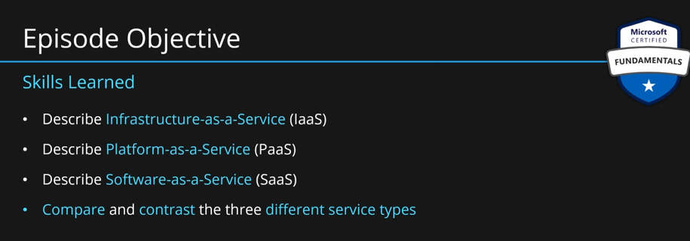

If we have a company and we want to run our applications, we need some infrastructure.

**Infrastructure** includes the **servers** we will need. Each **server** will have some memory, motherboards and CPU. We also need **storage** on our servers, it could be HDD or SSD. We need to connect our servers to the internet as well. For that we need some **networking** ie routers, switches or ethernet. We also need to divide our servers into logical machines called **virtual machines** through **virtualization**. All four or these make up the **infrastructure**.

We will also have an **operating system** running on these **virtual machines** ie windows or Linux. We will also have some **middleware software**. These include all the software or systems that you need in order to run the application. You will also need some **runtime** which will host your application. In case of web application, this could be **IIS**. If it is a container application, this could be a **docker**. **Runtime** is an additional layer which helps maintaining the application. All of these make up the **platform** for the application.

Finally, we store the **application** **and its data** on the **platform**. This is **application or software**.

All the layers which are directly related to the **hardware and virtualization** are called **infrastructure**.

All the **software or systems or configurations** which are required to **run the application** but not the application itself are called **platform**.

The **application/software** which we want to **run** is called **software**.

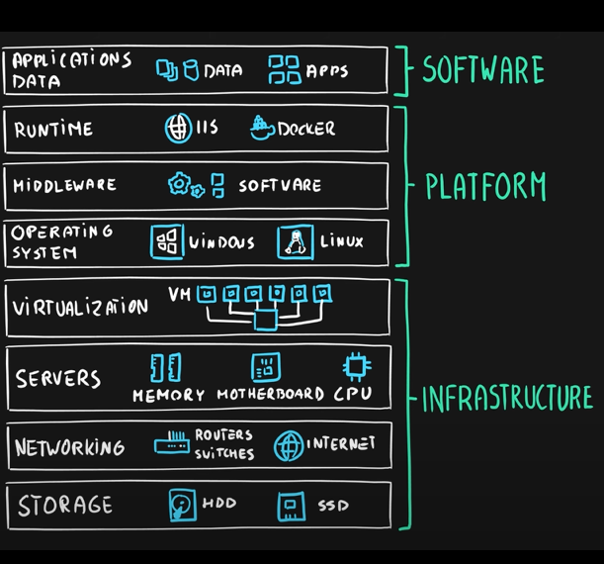

**Who manages what?**

If you manage all of these layers, then it is **on-premises**. All the ownership is on you in this case. You manage all the infrastructure, platform and the software and cloud provider is not even involved.

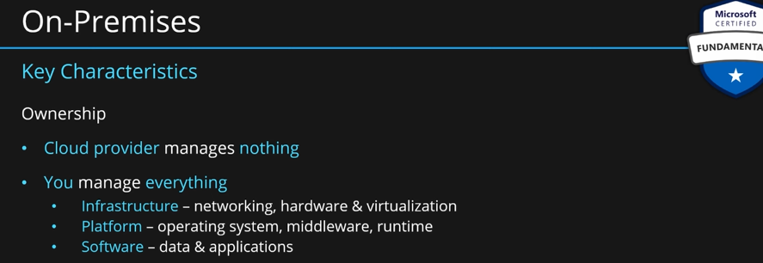

If you decide to outsource the infrastructure, so that Microsoft manages the infrastructure, and you manage the platform and the software. This is called **Infrastructure-as-a-Service (IaaS).**

**Infrastructure** is managed by cloud provider that is Microsoft. Platform and software is managed by you then it is **Infrastructure-as-a-Service (IaaS).**

Some **use cases** can be:

**Development and testing**: IaaS can be used for program testing and development, and for hosting complex websites. The computing and networking power of IaaS makes it a good environment for managing testing and development cycles.

**Data storage and analytics**: IaaS can be used for data storage, analytics, and data warehousing workloads. It can also be used for big data analysis.

**Backup and recovery:** IaaS can be used for disaster recovery or backup solutions, and for improving disaster recovery preparation.

**High computing performance**: IaaS can be used for high-performance computing (HPC).

Customer-facing websites: IaaS can be used for hosting customer-facing websites and web applications.

**Handling traffic spikes**: IaaS can be used for handling spikes in traffic.

**Provisioning resources quickly**: IaaS can be used for provisioning resources quickly.

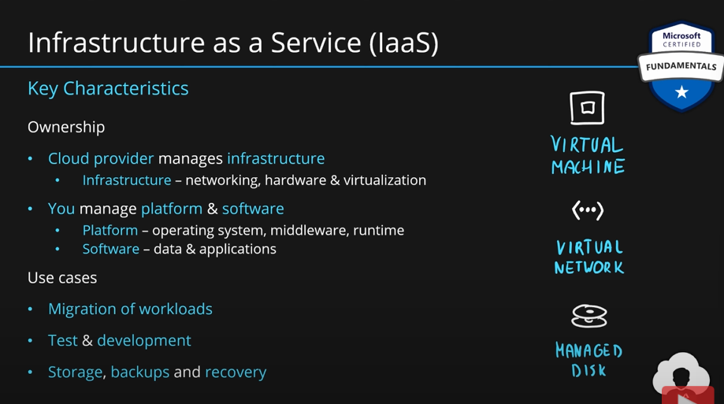

MS uses virtual machine, virtual network, managed disks and many others for **IaaS**. If some has **IaaS,** this basically means that they have a lot of **virtual machines.**

### Describe platform as a service (PaaS).

If we allow MS to manage infrastructure and the platform and we just **build our application**, then this becomes **PaaS.** So, besides the hardware (infrastructure), MS will also manage the OS, middleware and runtime. We will build our application and manage our application data on this platform.

We use this, whenever we are building a **cloud application**. This could be a **web application, AI, machine learning or business analytics** or anything else. If you are building an application, you are most likely using a **PaaS** service.

**We can have SQL for databases, App service for web hosting, Logic apps for enterprise integrations, function apps for serverless.**

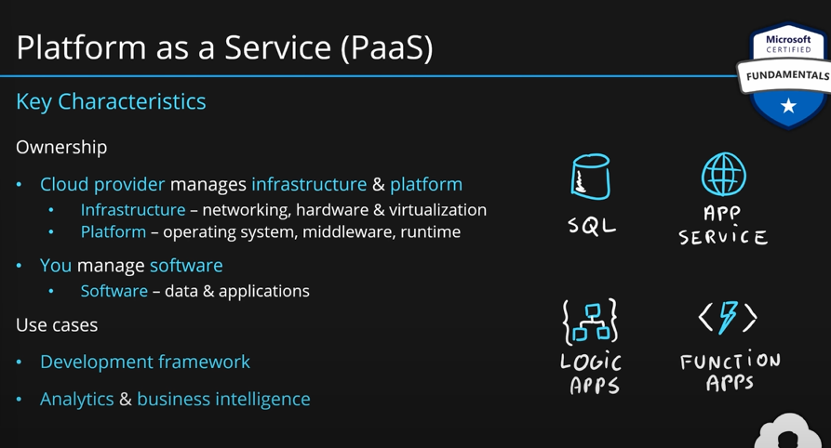

### Describe software as a service (SaaS).

If we outsource everything to MS, that means we are using **SaaS.** Everything ie infrastructure, platform, application and data are managed by MS. There is **nothing we need to manage**.

These are buying of the **shell application eg outlook, skype, OneDrive** and all the other business applications which we use every day**. We just use the application/software**. We don’t manage anything of the application/software.

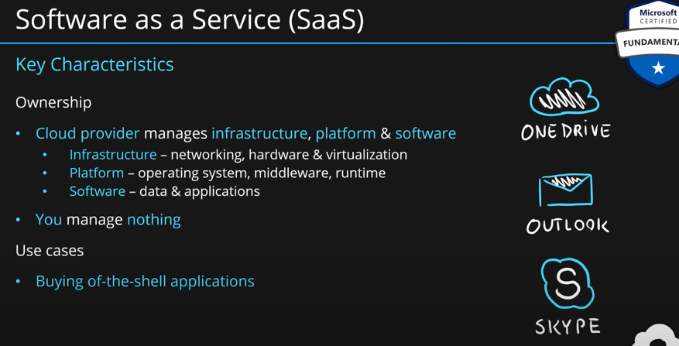

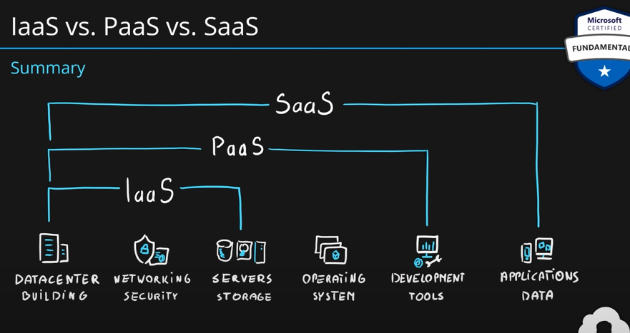

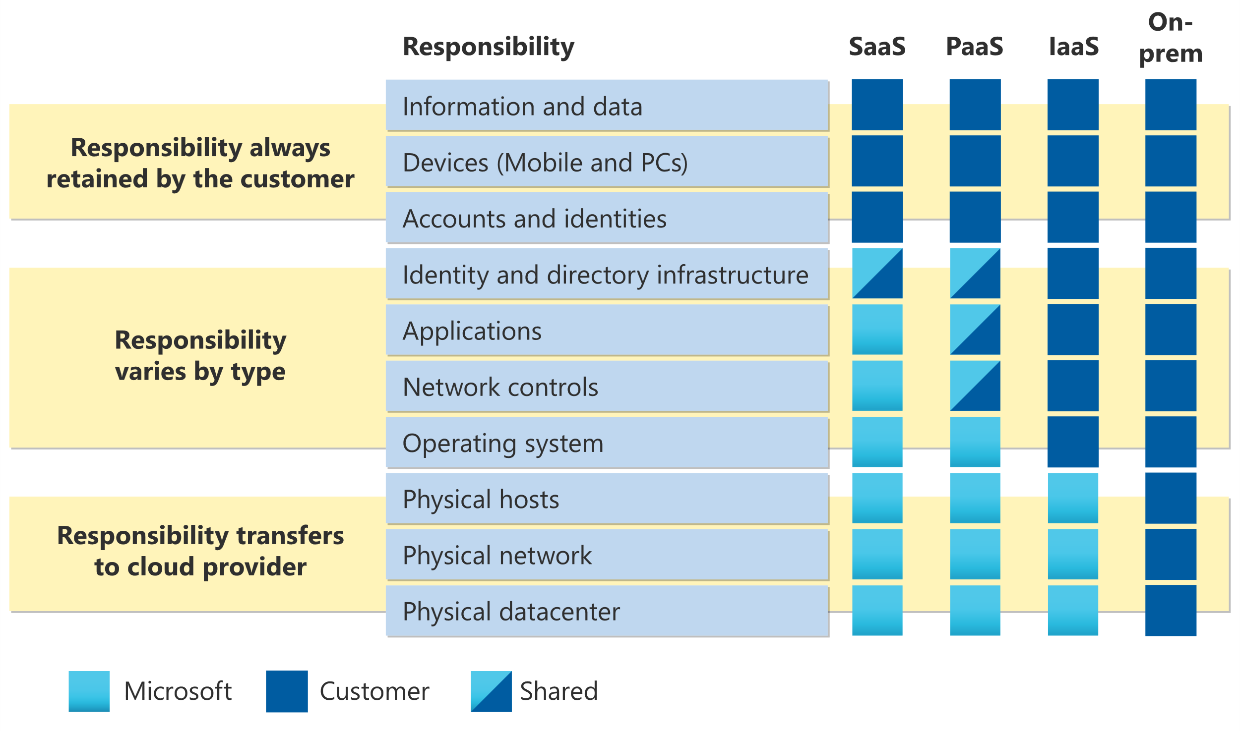

### Identify appropriate use cases for each cloud service type (IaaS, PaaS, and SaaS).

If you’re planning on using Azure, it’s important to understand how the different deployment models differ and what your options are. Here’s a quick guide to help you decide which deployment model is best suited to your needs:

**The Azure platform offers three main types of services: infrastructure as a service (IaaS), platform as a service (PaaS), and software as a service (SaaS).**

**IaaS** is the most feature-rich deployment model but requires you to set up your own servers and storage. It also comes with more overhead for managing. It gives you the most control over your environment but requires more effort to manage. You can also choose to run any software on top of an IaaS platform that meets your needs—for example, if you need a server for running PHP applications or MATLAB scripts, then you can use AWS.

IaaS is great for applications that require a lot of compute power, but don’t need much more than basic services like HTTP and log collection. This includes things like web servers, word processors, databases and file storage systems—anything that needs to run in isolation from other services within your organization’s infrastructure.

**PaaS** is more like a fully managed service where your code runs on Microsoft’s servers in the cloud, and you don’t have to worry about server configurations or maintaining them yourself—you just use it like any other application running on top of Windows Server. This can be great if you’re looking to build something quickly without having to worry about setting up all these underlying components yourself or keeping track of their performance metrics through alerts/statuses etc., but there are certainly some downsides too since having an entire infrastructure means that someone else will have access rights over those resources if needed for maintenance purposes; this includes things like adding new hardware into place (which could easily cause downtime) or making adjustments within certain areas such as security settings.

PaaS, you have access to a larger set of managed services than with IaaS or SaaS, but you don’t control the underlying environment. An example of this would be if your company wanted to use Amazon Web Services as its primary cloud provider but wanted to manage its own servers using Virtual Machines in the same data center. In this case, you would choose PaaS for your application because it allows more flexibility in how it’s deployed and managed than other options (especially because this is where we’d likely start).

The main benefit here is that it can help companies focus on their applications without worrying about infrastructure needs or scaling up/down according to demand. The downside? You’ll need some technical know-how before jumping into things like deploying VMs on AWS—and if there are any hiccups along the way then downfalls could potentially impact business operations too!

**SaaS is the simplest deployment model – entirely managed by Microsoft.**

It’s easiest to deploy SaaS applications when you have a lot of users, but it doesn’t have to be that way.

You don’t need to install software or configure hardware. A cloud service provider manages all of that for you, so there’s no need for your IT department (or even your CEO) to spend time on these tasks.

There are no updates needed as long as the application is in service—and most of them will be automatically applied by Microsoft Azure servers every few minutes or hours depending on how frequently they’re updated by their creators; this means that if something goes wrong with an app update then it should automatically roll back without any intervention from either yourself or anyone else at all! This also makes security much easier because any damage done during an update can easily be undone later down the line without having anything changed other than merely removing some files from its root directory instead of deleting them completely from memory space altogether.

An example of IaaS would be an application that requires a database server, with an attached file share for storing data.

An example of PaaS might be an application that requires a SQL database to store data, with web and business tiers for processing. The service allows you to create an application and host it in the cloud. You don’t have to worry about managing the underlying hardware or operating system; this is all handled by the service provider.

This type of PaaS can be useful if you want to quickly get started with your new project without having to spend time configuring servers or installing software on them (although there are some limitations). It also allows you to keep costs down because your initial investment is paid upfront as long as you meet certain requirements (e.g., number of users). However, it does require that developers learn how their apps will run in production before launching them into production environments where they could potentially impact other users’ performance or cost-effectiveness of operations overall; therefore providing an incentive for businesses interested in adopting this technology methodically over time may require additional resources like consultants who specialize only in designing custom applications using these platforms rather than just focusing on activities related directly related directly – such as developing software modules themselves…

SaaS is the simplest deployment model, and it’s also the most popular. It requires no on-premises infrastructure to use. An example of this is Office 365, which does not require any on-premises infrastructure to use.

If you’re looking for a cloud service provider that can host your application without requiring any additional hardware or software, SaaS may be the best option for you. However, not all applications are well suited for this type of deployment model; if yours does not fit one of these categories, then PaaS would be a better choice for your needs:

PaaS has optional features such as database management tools (e.g., MySQL) that allow users to manage data themselves rather than relying solely on service providers like Microsoft Azure/Amazon AWS etc.

PaaS offers greater flexibility in terms of customization options since developers have access directly through APIs rather than having them mediated by an external organization like Microsoft Azure/Amazon AWS etc.

When choosing which deployment model to use, consider how much control you need over your environment and what resources are available to manage it.

**Conclusion**

In short, your choice of deployment model depends on your needs and expectations. IaaS is the most powerful, but it comes with a learning curve and an increased risk of downtime. PaaS offers many benefits for organizations that need to manage their infrastructure as well as their applications; however, it does not have the same level of customization or flexibility as IaaS does. SaaS is the easiest option since you don’t need any servers or software installed; however, it can be difficult to set up if you don’t already have an account with Microsoft.

# Describe Azure architecture and services (35–40%)

## Describe the core architectural components of Azure.

### Describe Azure datacenters.

When you’re working with your own applications and business needs, you need to create an Azure account, and a subscription will be created for you. After you've created an Azure account, you’re free to create additional subscriptions. For example, your company might use a single Azure account for your business and separate subscriptions for development, marketing, and sales departments. After you've created an Azure subscription, you can start creating Azure resources within each subscription.

**Create an Azure account:**

You can purchase Azure access directly from Microsoft by signing up on the Azure website or through a Microsoft representative. You can also purchase Azure access through a Microsoft partner. Cloud Solution Provider partners offer a range of complete managed-cloud solutions for Azure.

**The Azure free account includes:**

* Free access to popular Azure products for 12 months.
* A credit to use for the first 30 days.
* Access to more than 25 products that are always free.

**What is the Azure free student account?**

The Azure free student account offer includes:

* Free access to certain Azure services for 12 months.
* A credit to use in the first 12 months.
* Free access to certain software developer tools.

The Azure free student account is an offer for students that gives $100 credit and free developer tools. Also, you can sign up without a credit card.

**Describe Azure physical infrastructure:**

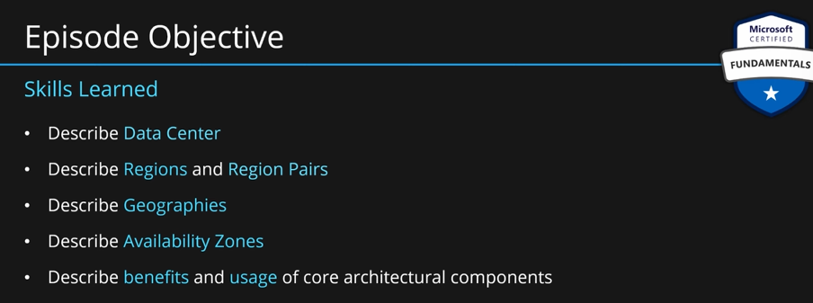

**Data Centers:** All the services provided by azure be it SQL database, web hosting, or VMs or any of the services provided by azure run-on **physical infrastructure** underneath ie some sort of servers. A physical facility that hosts those servers is called a data center. It is used to host a group of networked servers.

A typical data center has its own power, cooling, and networking infrastructure. Data centers are building blocks of global azure infrastructure.

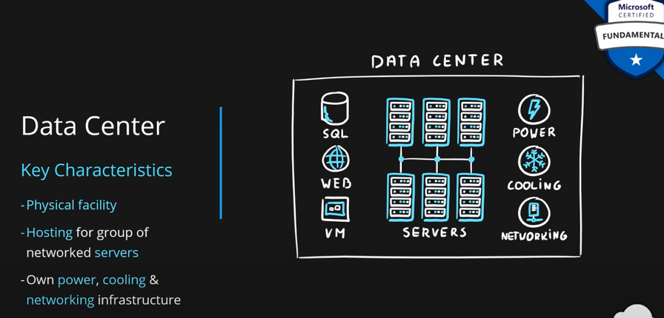

### Describe Azure regions, region pairs, and sovereign regions.

**Regions:** A group of data centers connected with high throughput internet connectivity are called **regions.** Microsoft has many regions of different sizes across the globe. A **region** can be as small as a single data center, or they can have many data centers. They are globally distributed.

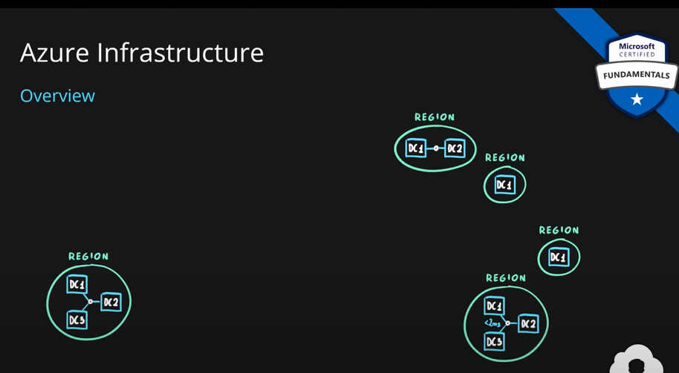

Eg in the US we have, one in West US and one in East US. In Ireland, we have north Europe region. In Singapore, we have southeast Asia region. In Japan, we have Japan east. And plenty more.

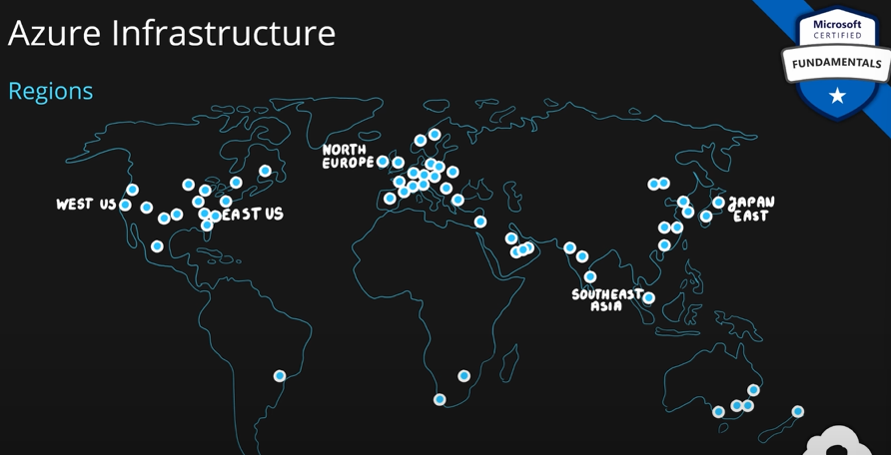

Azure developer should choose a region which is closest to the customer. This way the latency is low as the client and server are closer to each other.

**Characteristics of regions:**

1. They are geographical area on the planet.
2. One but usually more datacenters connected with low-latency network (<2 ms)
3. This is the location for your services. This means where your service physically is.
4. Some services are available only in certain regions.
5. Some services are global services, such are not assigned/deployed in specific regions.
6. Azure is globally available with 50+ regions.
7. Special govt regions (US DoD Central, US Gov Virginia, etc.)
8. Special partnered regions (China East, China North), here Microsoft provides are services but doesn’t really manage or run the data center themselves.

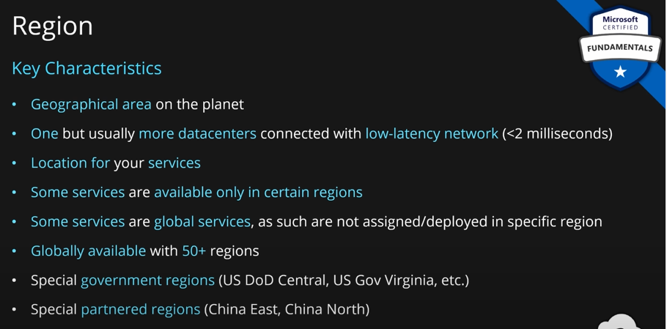

To see about the location. Let’s create a storage account which is a service to store files:

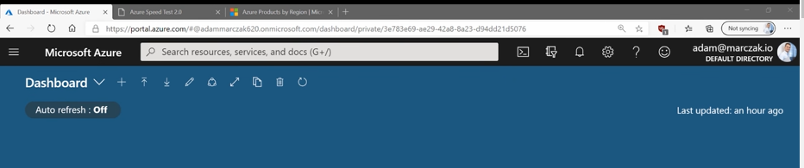

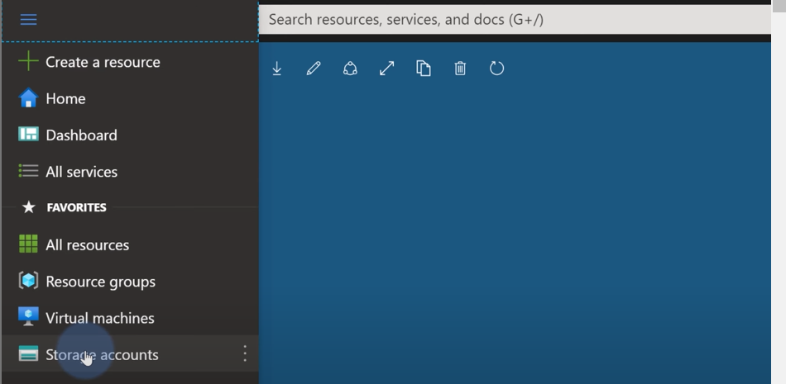

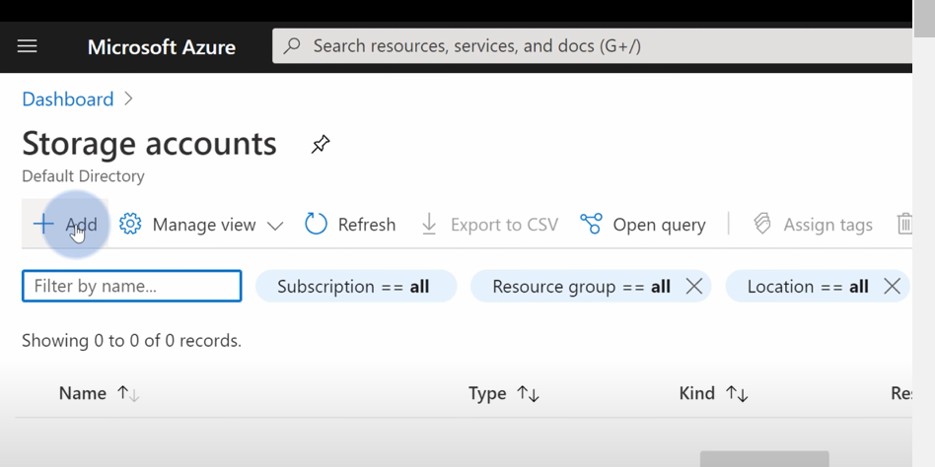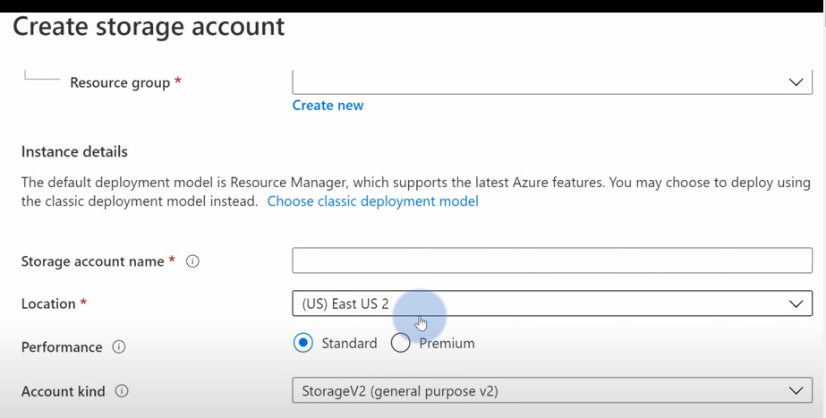

When selecting a location, we can pick up a region closest to us. But this is not always the best option because not all azure services are available at all azure regions. We can choose a region lit bit away, but it should have more azure services.

To help us take this decision, MS provides two portals:

**Azure Speed Test:**

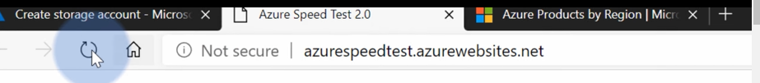

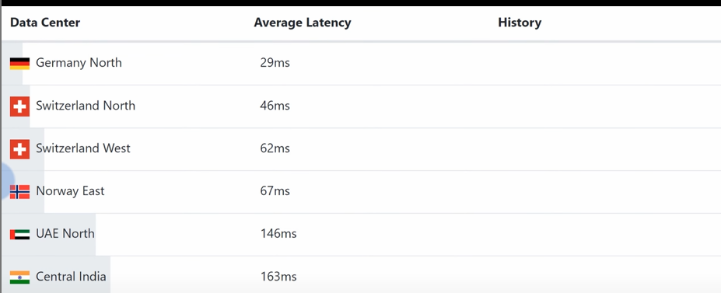

This service provides the latency between your location and all the azure regions.

**Products Available by Region:**

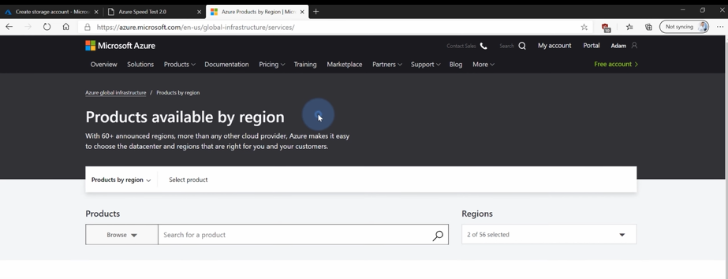

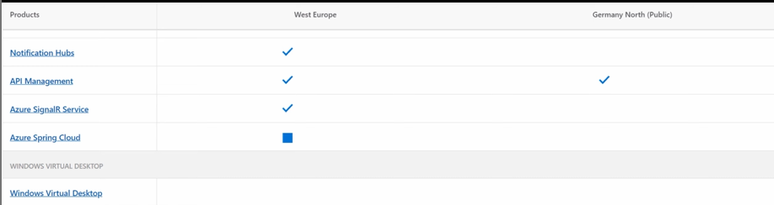

You can select regions on this page and this page tells us which azure services are available at what regions.

You can select a region which is closer to your location or your clients/customers location but also provide services which you need now or may need in the future. To make your decision future proof, choose a region which has more services.

### Describe availability zones.

We have multiple data centers inside a region. Each data center has their own power, cooling and networking infrastructure and they are connected with super-fast internet. Typically, we don’t have any control over which data center our service is deployed to when we choose a region. For this, availability zones were created.

Each data center gets a number. This number represents a grouping of physically separated facilities. Availability zones are designed to protect from data center failures. Each availability zone has its own power, cooling, and networking infrastructure.

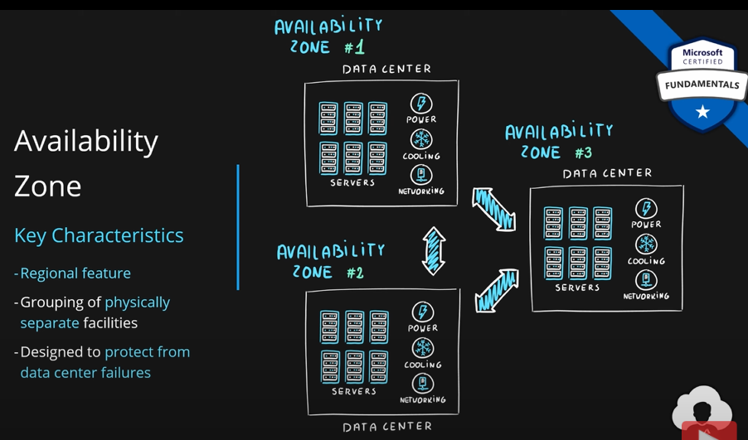

Whenever there is a failure in one availability zone other will continue to work.

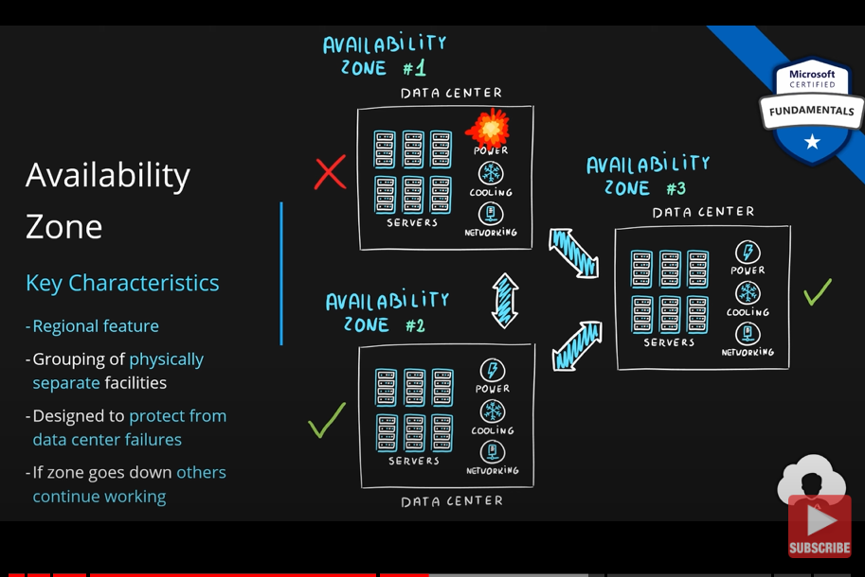

But this is how data centers work. So, how does availability zones make a difference.

MS has created services and features withing those services which can take advantage of this information. Those services are split into two categories.

1. **Zonal Services:** These services allow you to choose which availability zones are you doing the deployment of your service to. Eg VMs, you have a choice with VMs, which availability zone you want to deploy it to. You can create two VMs in two different availability zones within the same region for **high availability.** If one zone goes down, you can still use your other VM.

Without availability zones, it is possible that your VMs even in big regions might get deployed to the same data center or even to the same physical server. This is where zonal services in availability zone helps.

1. **Zone Redundant service:** These services allow you to take advantage of multiple availability zones out of the box. With simple check of a box, your service will automatically replicate data across multiple availability zones. So, your data will be in multiple data centers. This is redundancy. If a data center goes down, your data will be available. You wont even notice data center failure.

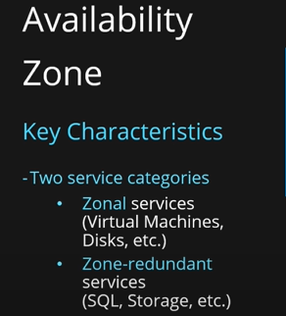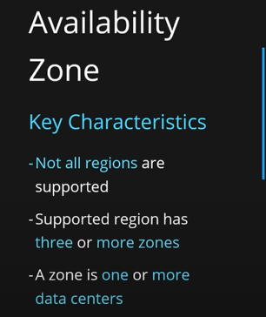

Not all regions support availability zones. **If a region supports availability zones, then there must be at least three or more zones.** **This means that for a region to support availability zones there is at least three data centers required.**

**It is not necessary that an availability zone will be built from just a single data center. An availability zone might have multiple data centers in it.**

So, some of the azure regions will have logical groupings over their data centers making them **zone enabled regions. Zone enabled regions** are basically those regions which support availability zones. Region must have at least three or more availability zones for it to be zone enabled.

While we were creating a storage account, we have below option:

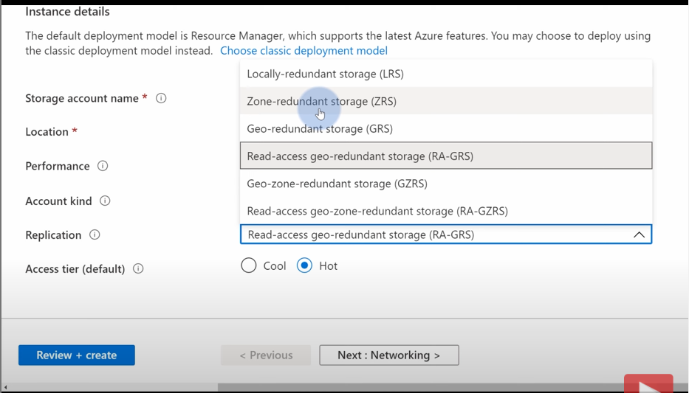

If we select **Zone-redundant storage (ZRS)** in replication, then this storage account will automatically replicate across multiple availability zones. This is happening because we have selected a region that supports availability zones or is zone enabled.

Let’s see how we can select availability zone while creating a **zonal service** eg a VM.

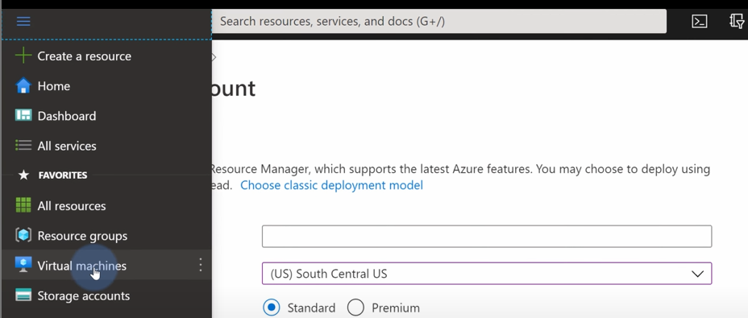

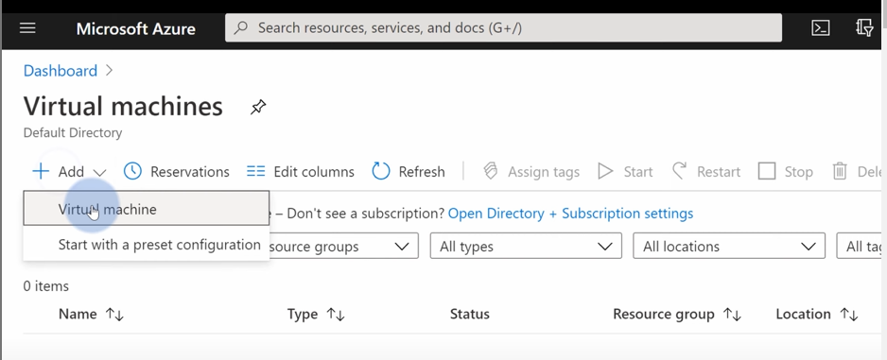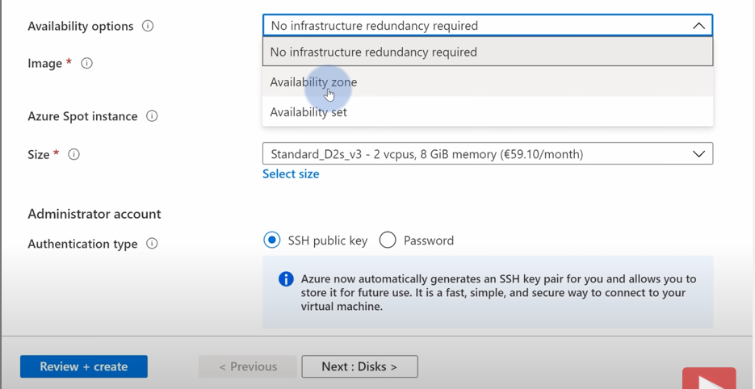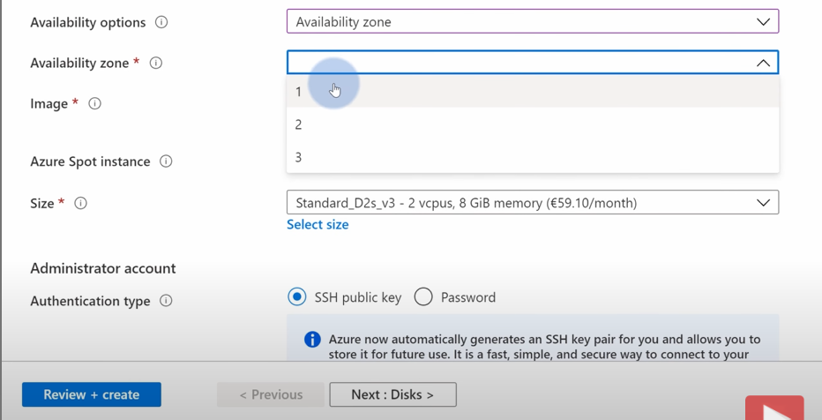

**For Zonal services, we can choose an availability zone manually. For zone-redundant services, we can choose whether we want zone-redundant or not. This is the difference between zonal services and zone-redundant services.**

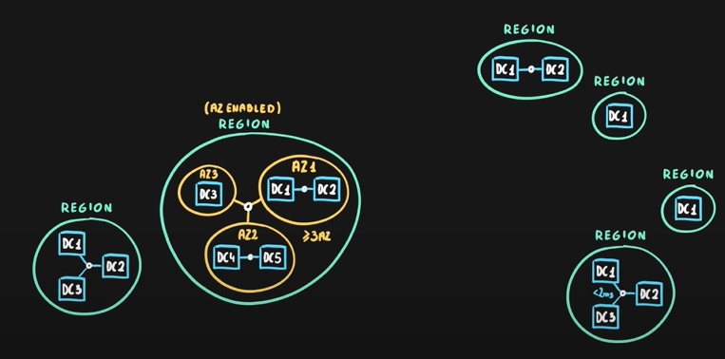

**What happens when an entire region breaks down. Then it does not matter if you have used availability zones or not.**

**Region Pairs:**

For this reason, ms has created region pairs. Each region has a region pair. Paired regions are at least 300 miles away from each other. This is to ensure that there is enough distance to cover natural level disasters such as floods, storms, earthquakes etc. With this, if a region goes down, the other region in the pair remains up. This gives us the features to replicate our data/application across multiple regions.

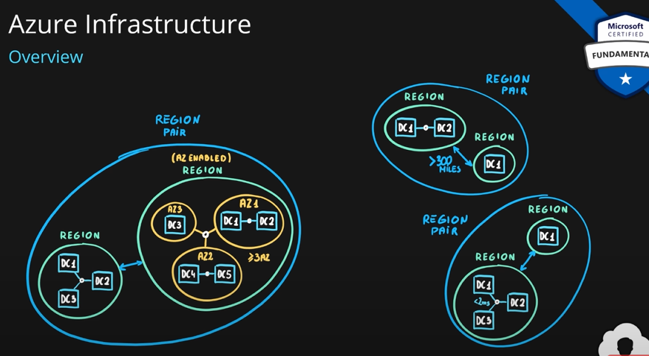

* Each region is paired with exactly one other region.
* Region pairs are static and cannot be chosen. You can’t change which region will pair with which region. Check the docs to know which region pairs with your region.
* Each pair resides within the same geography.
* Region pairs have at least 300 miles distance between them.
* Some services have platform-provided replication. With single click you can replicate your data and services across multiple regions. This protects you against region level failures.
* MS makes sure updates don’t happen to paired regions at the same time. So, the platform updates don’t affect your region.
* You can replicate to other regions as well but replicating to paired region is advised.

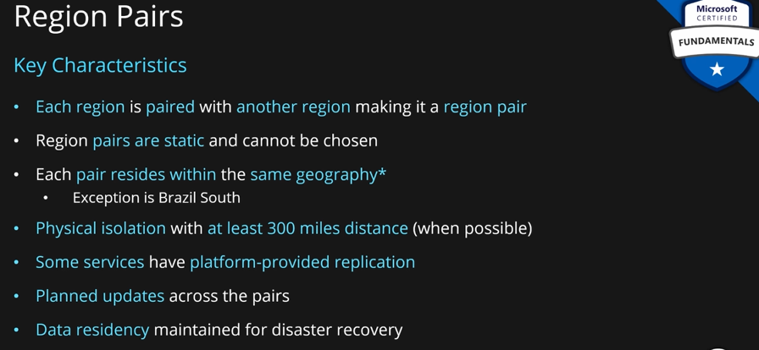

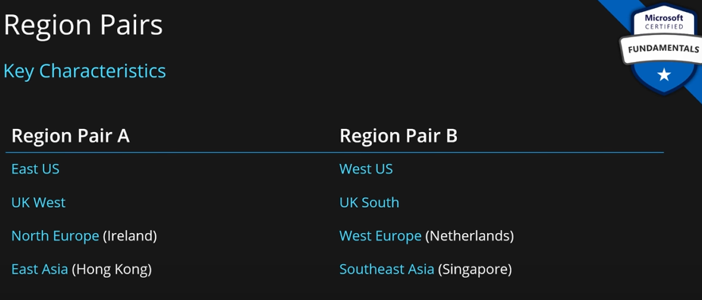

**Region pairs should be close enough to ensure high speed connectivity but far enough to avoid natural disaster at both regions.**

**Not all Azure services automatically replicate data or automatically fall back from a failed region to cross-replicate to another enabled region. In these scenarios, recovery and replication must be configured by the customer.**

Most regions are paired in two directions, meaning they are the backup for the region that provides a backup for them (West US and East US back each other up). However, some regions, such as West India and Brazil South, are paired in only one direction. In a one-direction pairing, the Primary region does not provide backup for its secondary region. So, even though West India’s secondary region is South India, South India does not rely on West India. West India's secondary region is South India, but South India's secondary region is Central India. Brazil South is unique because it's paired with a region outside of its geography. Brazil South's secondary region is South Central US. The secondary region of South-Central US isn't Brazil South.

**Azure Sovereign Regions:** We already know about azure regions. They are called public cloud regions. All are accessible from anywhere in the world and any customer can use them. Apart from those we also have sovereign regions. In the world, there are markets with specific compliance and security requirements. In order to meet the requirements and compliance, MS created special regions called sovereign regions.

1. **Azure Government:** It is for the **US government**. In the US, there are specific regions designed for azure government security and compliance requirement. We have

* US Gov Arizona
* US DoD Central
* US DoD East
* US Gov Texas

These are highly regulated environment. These are created for US government to build applications in the cloud. Azure government is a separate instance of azure. There is even a separate portal where you can access azure government. Inside azure government, services follow separate lifecycle.

If you are looking to design any application for a sovereign region of azure, first check if that service is available. Not all the services are available in sovereign regions.

Also, azure sovereign regions are physically isolated. Only, authorized personnel can access those services and infrastructure.

1. **Azure China:** It is for **China.** This is a different region from others due to highly specifically compliance requirements in China. This also has separate services, separate life cycles, separate portal and is physically separated. Azure China is not operated by MS due to regulations and compliance; this region is operated by **21Vianet, a Chinese company.**

**Note: East Asia is a public cloud region which is in Hongkong. Hongkong is in China, but it is a public cloud.**

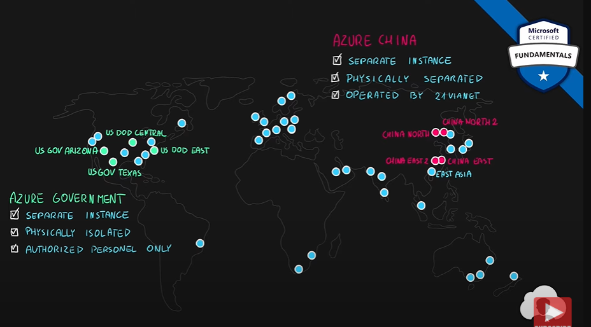

**Geography:** All regions and region pairs are grouped together into geographies.

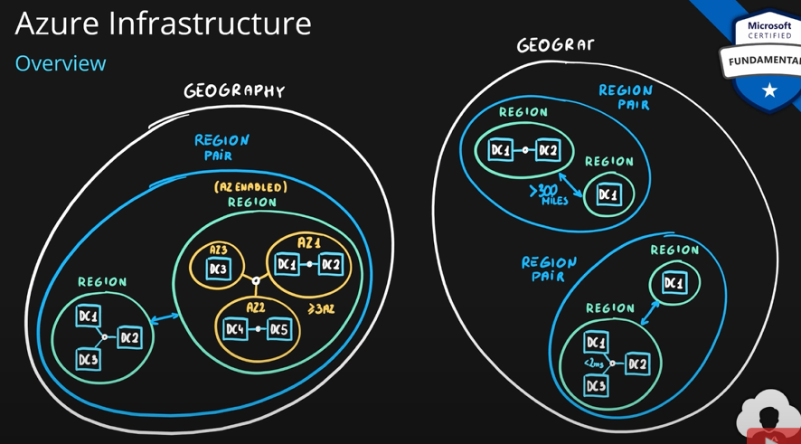

Each geography describes a discrete market. It contains typically two or more regions. They ensure that all data level requirements are met which are **data residency, sovereignty, resiliency, and compliance.** They also are **fault tolerant.** They protect against region or region pair level disaster.

Geographies are broken into areas:

* Americas
* Europe
* Asia Pacific
* Middle East and Africa

Each region belongs to one geography.

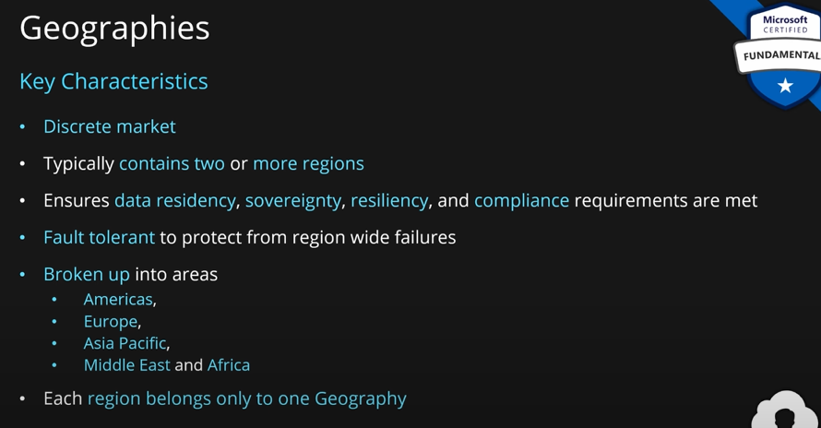

### Describe Azure resources and resource groups.

**Resource, Resource Groups, Resource Manager:**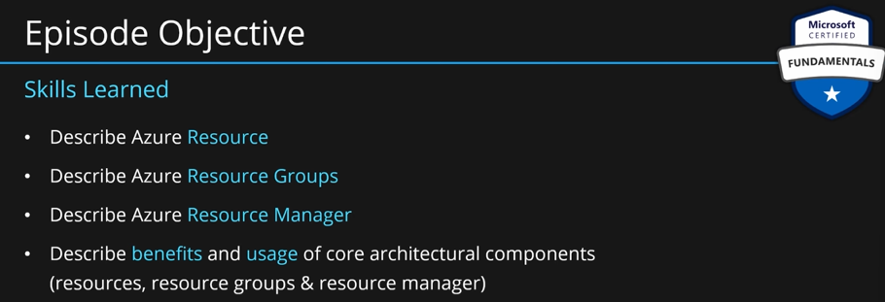

These are building blocks for management of Azure Services.

When users go to azure, they buy a service such as SQL DB, web app hosting, VM etc. Which service the user buy, they are represented as a generic object called **resource**. **Resources** are the objects which are used to represent and manage your azure services. They are contracts representing service life cycle. When you buy a service in azure, you create a resource. When you are done with the service and delete it, the resource is also deleted.

Azure uses resources to save all the configurations that you make for your service. Whatever configuration you do with your service, it is represented as a property of the resource.

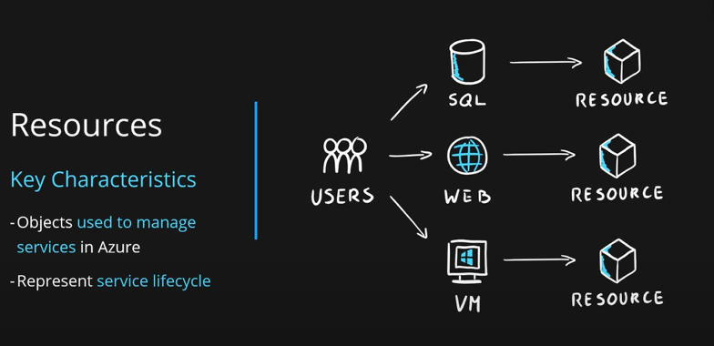

All the resources in azure can be represented as a **JSON template.** So, resources are saved as **JSON Definition.**

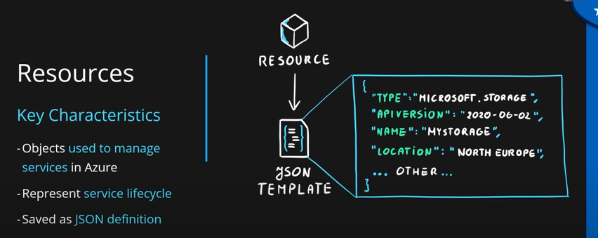

There are four common props every resource will have: **Type, API Version, Name, Location.**

**Resource Group:** They are logical container for all your resources. It is a requirement for creating any resource in Azure. You can put a number of resources inside a resource group.

You should put related resources inside a single resource group. This is not hard requirement. This helps in resource management.

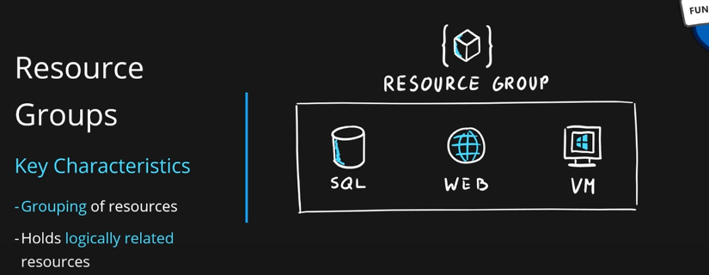

You can use any strategy you want to group your resources. Eg we can create one resource group for databases and another for web servers. Another strategy can be to group resources as dev, qa, prod. This way you can apply different scripts, policies, security rules, access management policies. Another way can be grouping by department wise. Another can be based on billing, location/region or a combination of both.

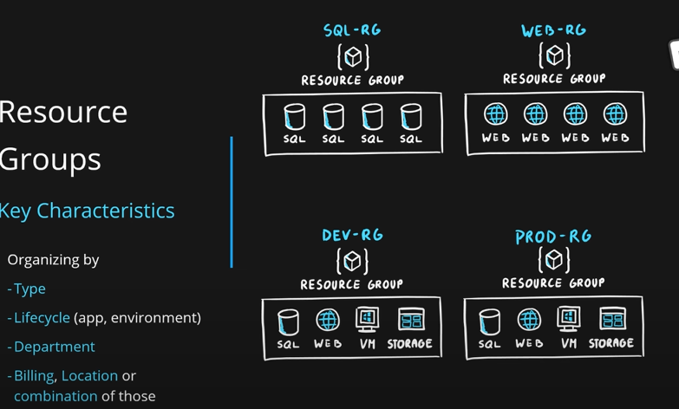

There are no hard rules. You can have your own strategy.

You can create the name of resources like this: **myapp1-dev-rg, myapp1-qa-rg, myapp1-prod-rg for myapp1 and myapp2-dev-rg, myapp2-qa-rg, myapp2-prod-rg for myapp2**. So, apps are separated and inside your app environment ie DEV or QA or prod is also separated. This is the most commonly used strategy in the market.

**Creating resource group is free.** First let’s create resource group.

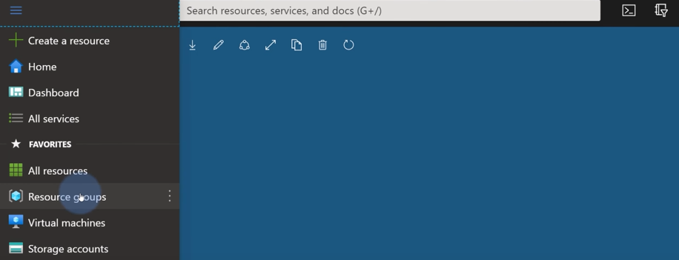 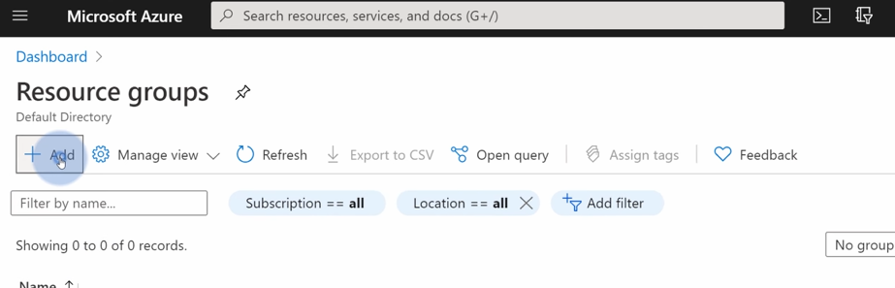

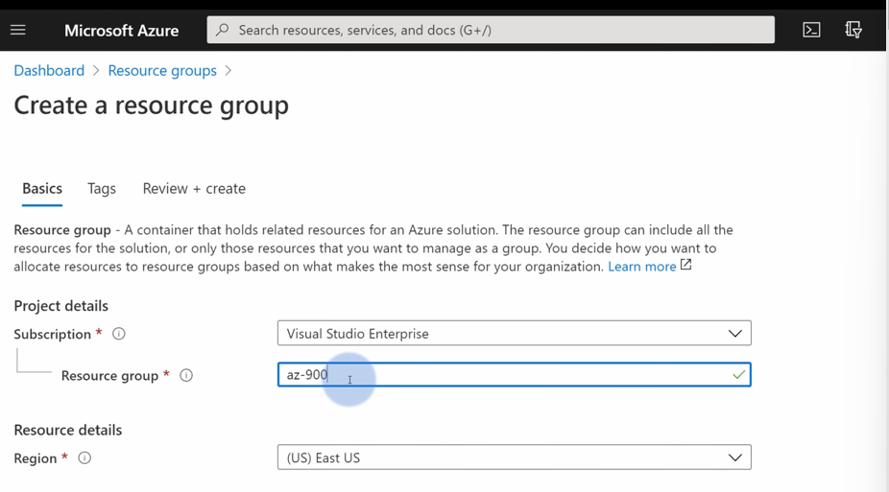

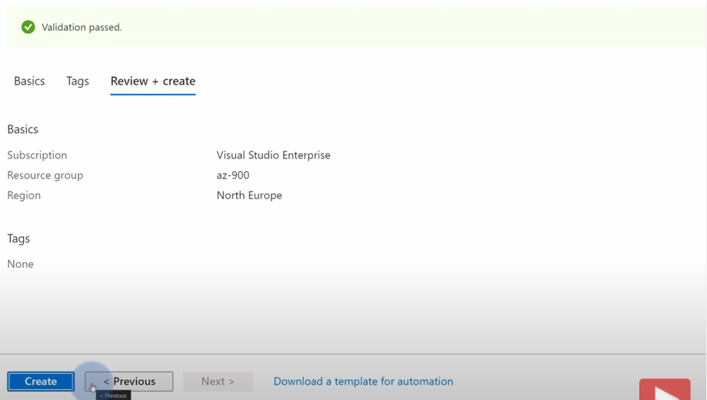

Let’s now go to this resource group and create resources inside it.

When you create a service, you always get an option to enter the resource group to which this service will belong. See the screenshot of creating a storage account service:

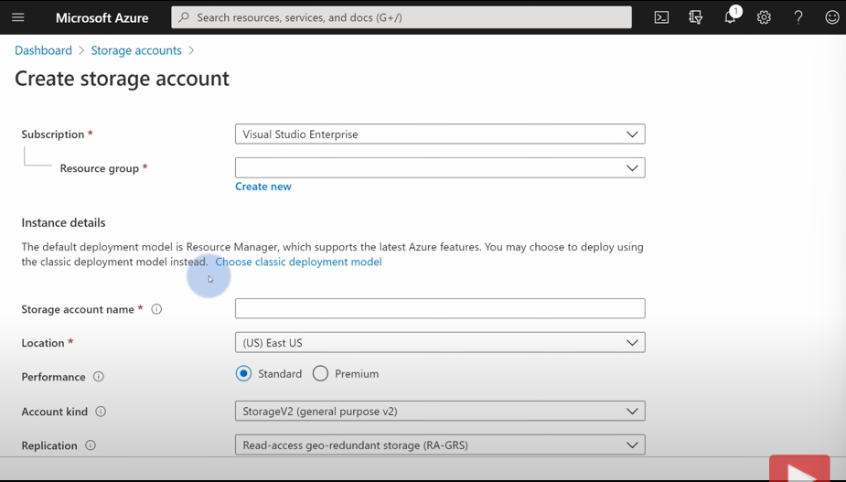

You can also see which fields are compulsory here.

There is also an **Access Control (IAM).**

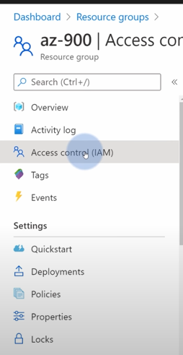 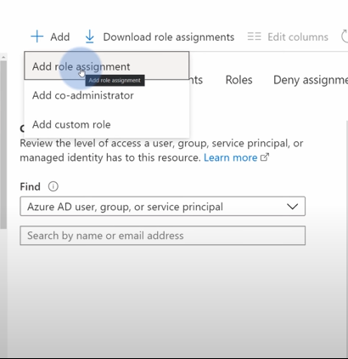 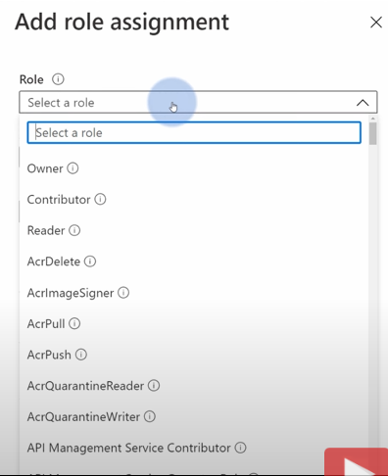

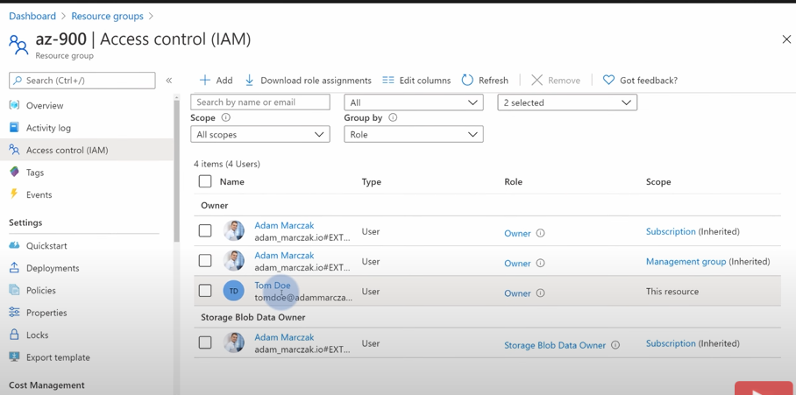

Owner means the user can do anything. We can assign roles to users here.

Anything you can do from portal, you can also do from the command line. This is **Azure CLI.** Some commands are: az login; opens a browser window and allows to login. Once logged in you can run commands in the CLI and manage azure.

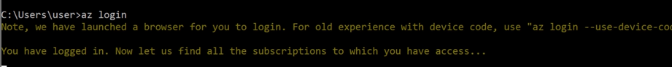

Managing azure resource and azure resource group is very easy to manage from CLI.





Another thing is azure resource portal: **resources.azure.com**

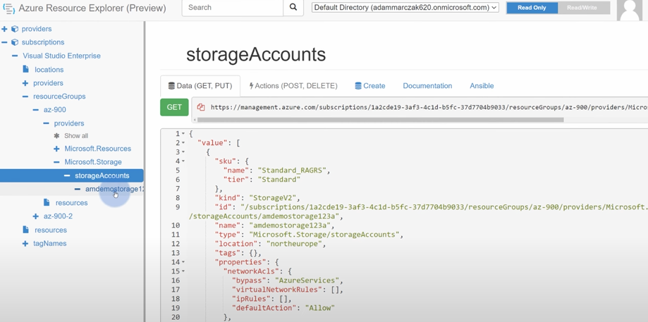

Here you can see all the props of your resource in **JSON format.**

**Summary:**

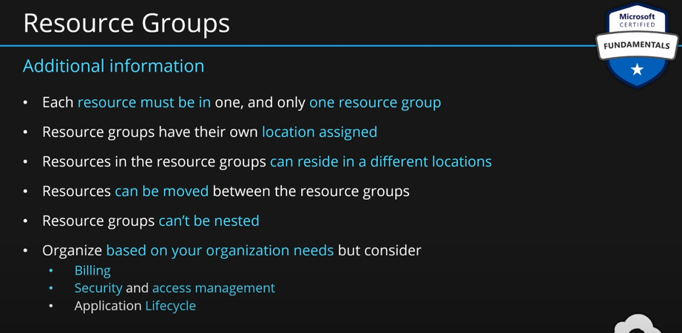

**Resouce Manager:** A user can create/buy a service using **Azure portal, rest APIs (Create scripts that will automate resource deployment), powershell, SDKs.** All of them connect to the same point, they all send the same same template at the end to create the resource. That point is **resource manager.**

**Describe features and tools for managing and deploying Azure resources:**

To get the most out of Azure, you need a way to interact with the Azure environment, the management groups, subscriptions, resource groups, resources, and so on. Azure provides multiple tools for managing your environment, including the:

* Azure portal
* Azure PowerShell
* Azure Command Line Interface (CLI)

**Resource manager:**

* **Governs all the resources/resource manager in azure. This can be creating/deleting/updating resource or resource manager.**
* **It is a unified language. So, you can create your resource through any method, same template will be used to create it.**
* **It also checks user’s privilages with Azure AD (Actice Directory) when user does any operations.**
* **It controls the access to the resourcess**

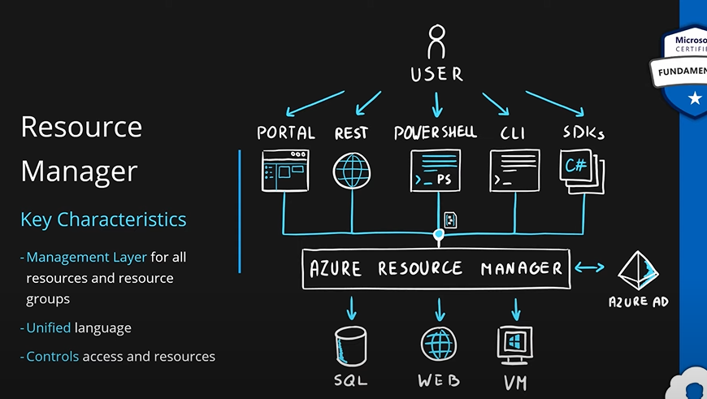

### Describe subscriptions.

**Azure subscriptions:**

In Azure, subscriptions are a unit **of management, billing, and scale**. Similar to how resource groups are a way to logically organize resources, subscriptions allow you to logically organize your resource groups and facilitate billing.

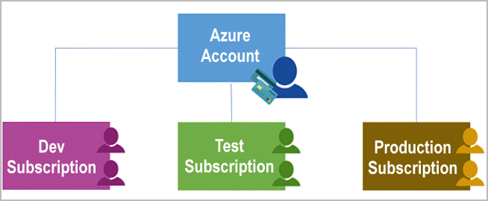

Using Azure requires an Azure subscription. A subscription provides you with authenticated and authorized access to Azure products and services. It also allows you to provision resources. An Azure subscription links to an Azure account, which is an identity in Microsoft Entra ID or in a directory that Microsoft Entra ID trusts.

An account can have multiple subscriptions, but it’s only required to have one. In a multi-subscription account, you can use the subscriptions to configure different billing models and apply different access-management policies. You can use Azure subscriptions to define boundaries around Azure products, services, and resources. There are two types of subscription boundaries that you can use:

**Billing boundary:** This subscription type determines how an Azure account is billed for using Azure. You can create multiple subscriptions for different types of billing requirements. Azure generates separate billing reports and invoices for each subscription so that you can organize and manage costs.

**Access control boundary**: Azure applies access-management policies at the subscription level, and you can create separate subscriptions to reflect different organizational structures. An example is that within a business, you have different departments to which you apply distinct Azure subscription policies. This billing model allows you to manage and control access to the resources that users provision with specific subscriptions.

**Create additional Azure subscriptions.**

Similar to using resource groups to separate resources by function or access, you might want to create additional subscriptions for resource or billing management purposes. For example, you might choose to create additional subscriptions to separate:

**Environments**: You can choose to create subscriptions to set up separate environments for development and testing, security, or to isolate data for compliance reasons. This design is particularly useful because resource access control occurs at the subscription level.

**Organizational structures:** You can create subscriptions to reflect different organizational structures. For example, you could limit one team to lower-cost resources, while allowing the IT department a full range. This design allows you to manage and control access to the resources that users provision within each subscription.

**Billing**: You can create additional subscriptions for billing purposes. Because costs are first aggregated at the subscription level, you might want to create subscriptions to manage and track costs based on your needs. For instance, you might want to create one subscription for your production workloads and another subscription for your development and testing workloads.

### Describe management groups.

The final piece is the management group. Resources are gathered into resource groups, and resource groups are gathered into subscriptions. If you’re just starting in Azure that might seem like enough hierarchy to keep things organized. But imagine if you’re dealing with multiple applications, multiple development teams, in multiple geographies.

If you have many subscriptions, you might need a way to efficiently manage access, policies, and compliance for those subscriptions. Azure management groups provide a level of scope above subscriptions. You organize subscriptions into containers called management groups and apply governance conditions to the management groups. All subscriptions within a management group automatically inherit the conditions applied to the management group, the same way that resource groups inherit settings from subscriptions and resources inherit from resource groups. Management groups give you enterprise-grade management at a large scale, no matter what type of subscriptions you might have. **Management groups can be nested.**

**Management group, subscriptions, and resource group hierarchy:**

You can build a flexible structure of management groups and subscriptions to organize your resources into a hierarchy for unified policy and access management. The following diagram shows an example of creating a hierarchy for governance by using management groups.

### Describe the hierarchy of resource groups, subscriptions, and management groups.

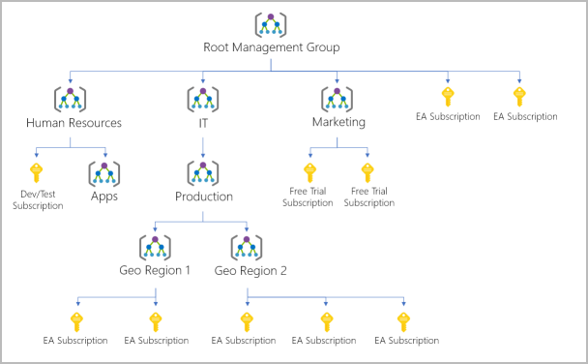

**Some examples of how you could use management groups might be:**

**Create a hierarchy that applies a policy.** You could limit VM locations to the US West Region in a group called Production. This policy will inherit onto all the subscriptions that are descendants of that management group and will apply to all VMs under those subscriptions. This security policy can't be altered by the resource or subscription owner, which allows for improved governance.

**Provide user access to multiple subscriptions.** By moving multiple subscriptions under a management group, you can create one Azure role-based access control (Azure RBAC) assignment on the management group. Assigning Azure RBAC at the management group level means that all sub-management groups, subscriptions, resource groups, and resources underneath that management group would also inherit those permissions. One assignment on the management group can enable users to have access to everything they need instead of scripting Azure RBAC over different subscriptions.

**Important facts about management groups:**

10,000 management groups can be supported in a single directory.

A management group tree can support up to six levels of depth. This limit doesn't include the root level or the subscription level.

Each management group and subscription can support only one parent.

## Describe Azure compute and networking services.

### Compare compute types, including containers, virtual machines, and functions.

**Virtual Machine (VM):**

**Virtualization:** We have a server/computer. We first install **OS** on that machine. Now, on top of that OS, we install **virtualization software**. **Virtualization software** will divide the space logically. And in each such part it allows to install a **virtual machine**. **Virtual machine is just an emulation of a physical machine**. Now, that VM will have an OS, a file system and more things just like a real physical machine. On that VM, we can host our application. Virtual machines are completely independent of each other. Whatever you do on one VM will not affect the other VM you have created on the same physical machine. Hence, you can emulate multiple virtual machines on a single physical machine which are independent of each other.

You can have different OS, different software on different VMs since they are independent of each other.

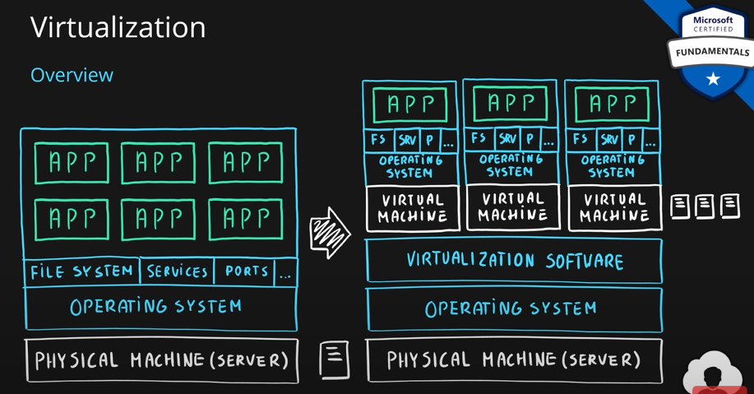

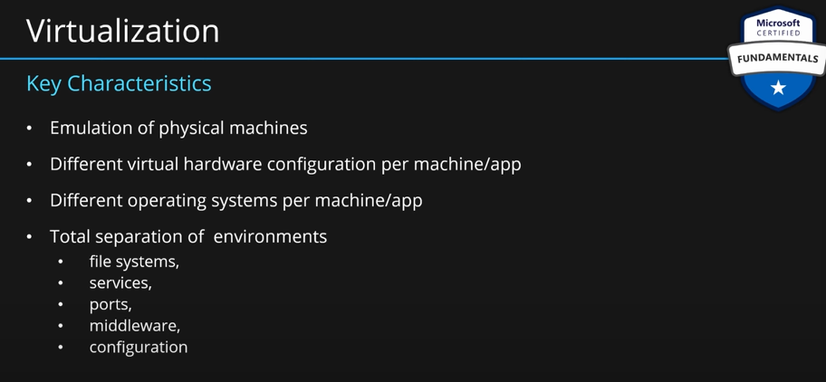

Virtualization is done through **Azure Virtual Machine Service.**

### Describe virtual machine options, including Azure virtual machines, Azure Virtual Machine Scale Sets, availability sets, and Azure Virtual Desktop.

**How VMs are created; two ways:**

You can take VM images (windows, ubuntu etc.) provided by MS in marketplace. Or you can configure your own system, install services, runtime and apps and create a custom image for your own company. You then put that image in some storage.

Azure virtual machine grab those images. It allows you to choose custom or marketplace image. Then a VM will be created and will be exposed to your users. With whatever image you provide, in a few mins, a VM will be created and provisioned.

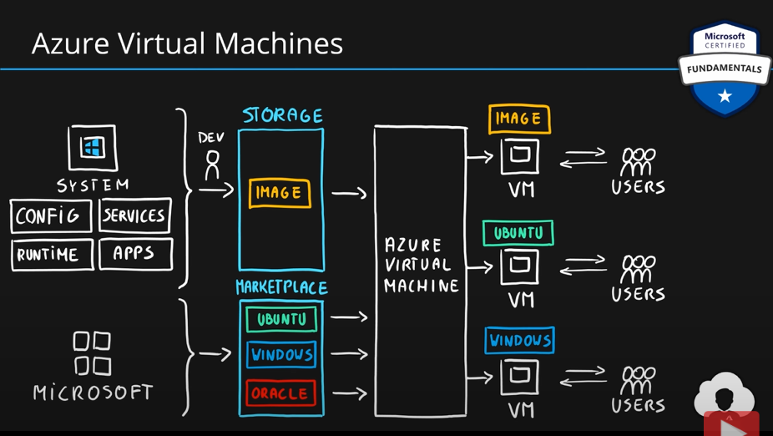

Key point to note is that **VM are IaaS.** This means that you are responsible for managing OS, platform and application. You have total control over the operating system and the software running on it. With the help of custom images, you can create a VM using your organizational configs. This also helps in lift and shift scenarios. You can lift and shift your on-premise to a VM without the need to redesign.

On VMs, we can run web apps and web services, databases, desktop applications, jump-boxes, gateways etc.

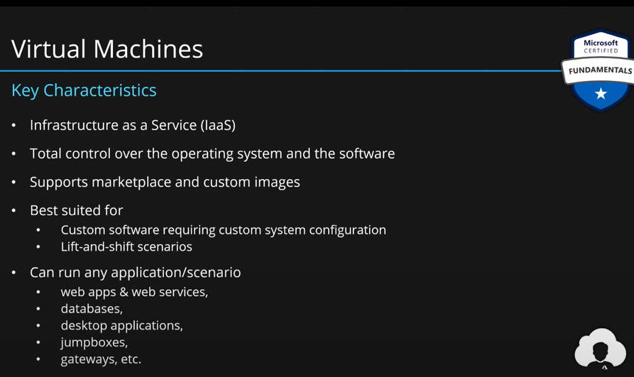

**How to create VMs in Azure:**

* Go to create resource.
* Go to compute section.
* Select Virtual Machine.
* Put all the values in the fields.
* Choose which image you want for your VM

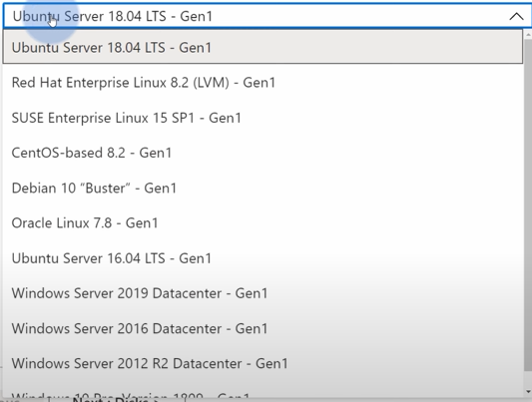

* Choose the appropriate size for your VM. Size means processor, ram etc.
* Provide username and password.
* Choose how would you connect to this VM 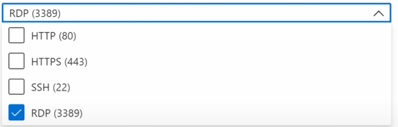
* Now hit review+create.
* Review all the details and hit create.
* In a few mins, your machine will be ready.
* Go to resource and here you can manage the VM
* If you selected RDP (Remote Desktop Connection) as connection method then if you click connect then it will download a .rdp file. You can open this file and it will connect you to your VM. You have to enter your username and password to connect.

**There is no autoscaling in VMs. Only way of scaling a VM is vertical scaling ie by adding for CPU and RAM, faster drives etc.**

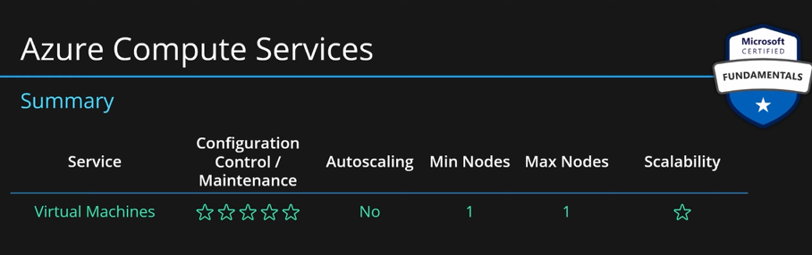

For this reason, we have azure provides **Virtual Machine Scale Sets.** With this service, you pick an image, custom or one from the marketplace. This image is automatically scaled across multiple VMs. These VMs are hidden behind a load balancer which directs the traffic among the VMs. Number of VMs can be set statically such as 3, 5 etc. or automatic with autoscaling feature. This will increase or decrease the number of VMs automatically based on application’s demand.

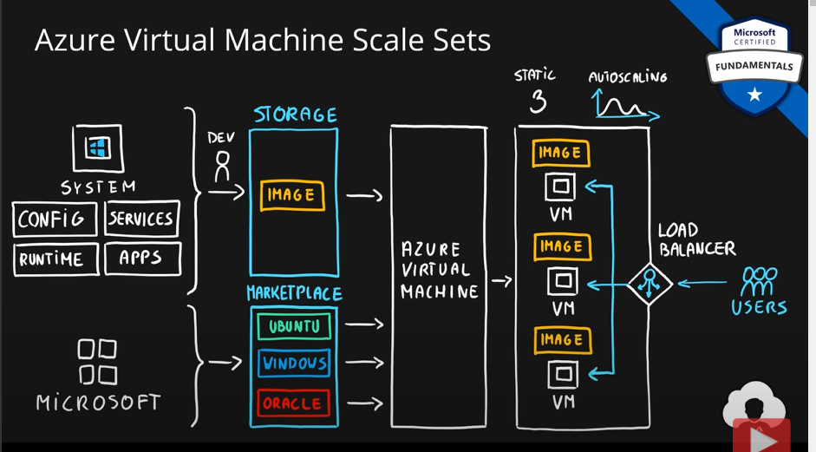

Virtual Machine Scale Sets are IaaS. Identical VMs are created. Built in autoscaling features.

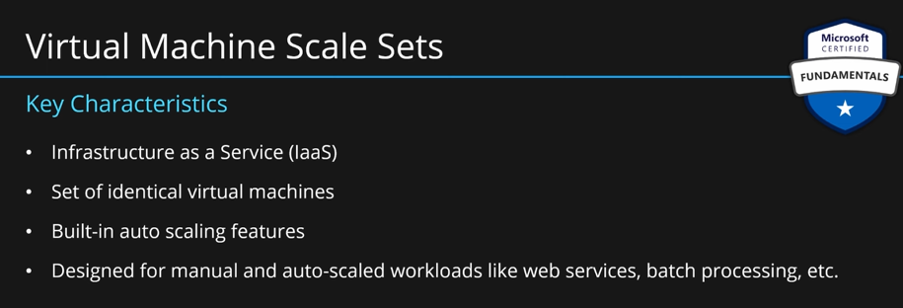

Virtual machine scale sets let you create and manage a group of identical, load balanced VMs. If you simply created multiple VMs with the same purpose, you’d need to ensure they were all configured identically and then set up network routing parameters to ensure efficiency. You’d also have to monitor the utilization to determine if you need to increase or decrease the number of VMs.

Instead, with virtual machine scale sets, Azure automates most of that work. Scale sets allow you to centrally manage, configure, and update a large number of VMs in minutes. The number of VM instances can automatically increase or decrease in response to demand, or you can set it to scale based on a defined schedule. Virtual machine scale sets also automatically deploy a load balancer to make sure that your resources are being used efficiently. With virtual machine scale sets, you can build large-scale services for areas such as compute, big data, and container workloads.

**Virtual machine availability sets**

Virtual machine availability sets are another tool to help you build a more resilient, highly available environment. Availability sets are designed to ensure that VMs stagger updates and have varied power and network connectivity, preventing you from losing all your VMs with a single network or power failure.

Availability sets do this by grouping VMs in two ways: update domain and fault domain.

**Update domain**: The update domain groups VMs that can be rebooted at the same time. This allows you to apply updates while knowing that only one update domain grouping will be offline at a time. All of the machines in one update domain will be updated. An update group going through the update process is given a 30-minute time to recover before maintenance on the next update domain starts.

**Fault domain:** The fault domain groups your VMs by common power source and network switch. By default, an availability set will split your VMs across up to three fault domains. This helps protect against a physical power or networking failure by having VMs in different fault domains (thus being connected to different power and networking resources).

Best of all, there’s no additional cost for configuring an availability set. You only pay for the VM instances you create.

**Examples of when to use VMs:**

Some common examples or use cases for virtual machines include:

**During testing and development**. VMs provide a quick and easy way to create different OS and application configurations. Test and development personnel can then easily delete the VMs when they no longer need them.

**When running applications in the cloud**. The ability to run certain applications in the public cloud as opposed to creating a traditional infrastructure to run them can provide substantial economic benefits. For example, an application might need to handle fluctuations in demand. Shutting down VMs when you don't need them or quickly starting them up to meet a sudden increase in demand means you pay only for the resources you use.

**When extending your datacenter to the cloud:** An organization can extend the capabilities of its own on-premises network by creating a virtual network in Azure and adding VMs to that virtual network. Applications like SharePoint can then run on an Azure VM instead of running locally. This arrangement makes it easier or less expensive to deploy than in an on-premises environment.

**During disaster recovery**: As with running certain types of applications in the cloud and extending an on-premises network to the cloud, you can get significant cost savings by using an IaaS-based approach to disaster recovery. If a primary datacenter fails, you can create VMs running on Azure to run your critical applications and then shut them down when the primary datacenter becomes operational again.

VMs are also an excellent choice when you move from a physical server to the cloud (also known as **lift and shift**). You can create an image of the physical server and host it within a VM with little or no changes. Just like a physical on-premises server, you must maintain the VM: you are responsible for maintaining the installed OS and software.

### Describe the resources required for virtual machines.

**VM Resources**

When you provision a VM, you will also have the chance to pick the resources that are associated with that VM, including:

* **Size (purpose, number of processor cores, and amount of RAM)**
* **Storage disks (hard disk drives, solid state drives, etc.)**
* **Networking (virtual network, public IP address, and port configuration)**

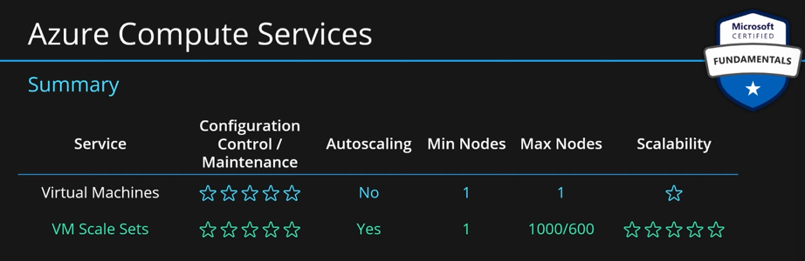

They are one of the most scalable services provided by Azure.

**Describe Azure virtual desktop:**

Another type of virtual machine is the Azure Virtual Desktop. Azure Virtual Desktop is a desktop and application virtualization service that runs on the cloud. It enables you to use a cloud-hosted version of Windows from any location. Azure Virtual Desktop works across devices and operating systems and works with apps that you can use to access remote desktops or most modern browsers.

**Enhance security:**

Azure Virtual Desktop provides centralized security management for users' desktops with Microsoft Entra ID. You can enable multifactor authentication to secure user sign-ins. You can also secure access to data by assigning granular role-based access controls (RBACs) to users.

With Azure Virtual Desktop, the data and apps are separated from the local hardware. The actual desktop and apps are running in the cloud, meaning the risk of confidential data being left on a personal device is reduced. Additionally, user sessions are isolated in both single and multi-session environments.

**Multi-session Windows 10 or Windows 11 deployment**

Azure Virtual Desktop lets you use Windows 10 or Windows 11 Enterprise multi-session, the only Windows client-based operating system that enables multiple concurrent users on a single VM. Azure Virtual Desktop also provides a more consistent experience with broader application support compared to Windows Server-based operating systems.

### Describe application hosting options, including web apps, containers, and virtual machines.

**Containers: Containers** are very similar to **VMs** but there is some difference. We have a physical server and an operating system just like a **VM**. But, instead of virtualization software, we install **container runtime**. Inside container runtime, we install **containers**. A **container** is **a sandbox environment** for each app. The major difference between a container and a virtual machine is that there is **no OS inside each container**. We have OS inside each VM but inside container, we don’t have OS. Therefore, **the footprint of a container is much smaller than a VM.**

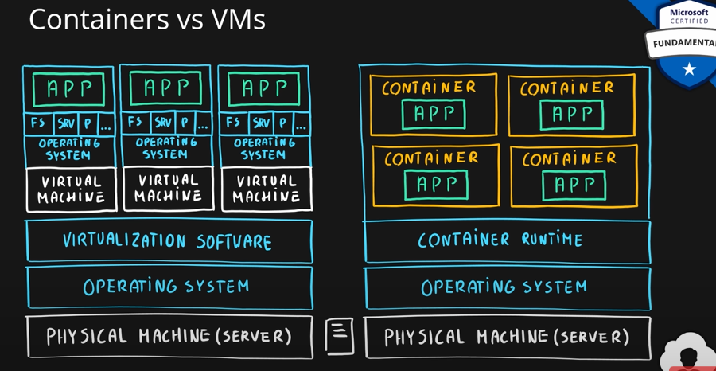

Container will use host’s OS. But the application needs an OS to run, so, container will emulate the OS. VMs emulate hardware, whereas container emulate software (OS). They are light wright than VMs. Less development effort is needed to create container. Less maintenance because you don’t need to patch and maintain OS. Less computation and storage due to the absence of OS.

You can also respond quicker in case of demand change because you don’t need to create OS.

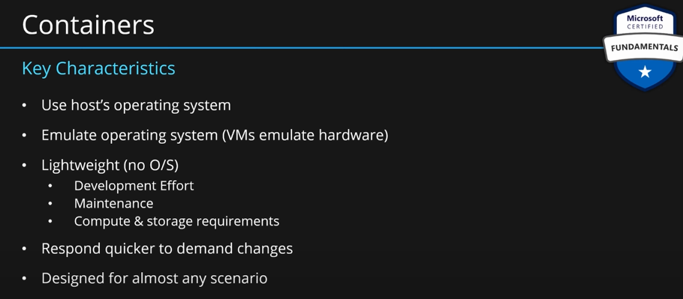

First service for container is **container instances.** Instead of bundling entire system, you take the application, its configurations and other runtime middleware software that you need for this application to run. Then you bundle all of it into an **image** and host/put that image in **container service.**

Like **VMs**, there is a public marketplace provided by azure which you can use. This marketplace provides images which you can use. Take the image and push it to **azure container instance**. It will create a VM which will have your containers.

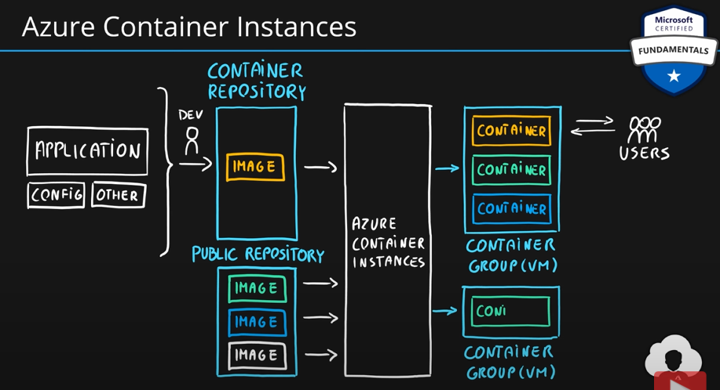

One of the most popular container engines is **Docker**, and Azure supports **Docker**.

**Azure Container Instances:**

* Simplest and fastest way to run a container.
* This is PaaS.
* Also called serverless containers.

Azure Container Instances offer the fastest and simplest way to run a container in Azure; without having to manage any virtual machines or adopt any additional services. Azure Container Instances are a platform as a service (PaaS) offering. Azure Container Instances allow you to upload your containers and then the service will run the containers for you.

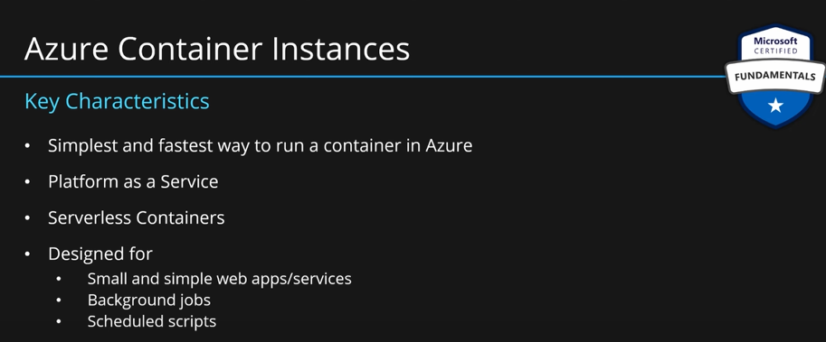

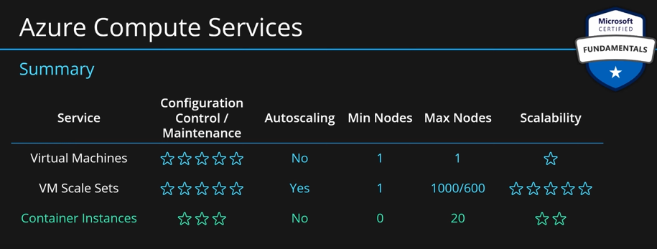

**This service is only for running simple tasks/applications. It does not support auto-scaling.**

**Azure Container Apps:** Azure Container Apps are similar in many ways to a container instance. They allow you to get up and running right away, they remove the container management piece, and they're a PaaS offering. Container Apps have extra benefits such as the ability to incorporate load balancing and scaling. These other functions allow you to be more elastic in your design.

**Azure Kubernetes Service (AKS):** Same as container service, you put your image in container repo. Then that image is deployed to **AKS. AKS** will spread these images across **nodes**. Nodes are VMs underneath. These details are abstracted from the user. **AKS** will manage the **deployment of containers** across those nodes. After deployment, **AKS** will expose everything (all the nodes) to users. It will put **a load balancer** in front of nodes to distribute traffic.

AKS will give you option to **auto-scale or static scaling.**

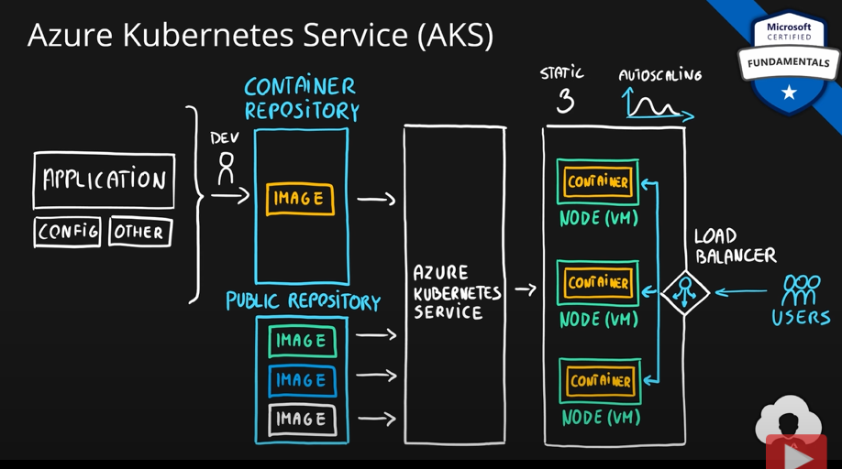

**AKS:**

* KS is open source. So, it is available across all clouds like AWS etc.
* It is PaaS.
* It is highly scalable and customizable.
* Container instances are designed for simple container deployments, AKS is designed for highly scalable and highly customizable containers in the cloud.
* As container are very similar to VMs, you can do almost everything in a container, you can do with VMs.

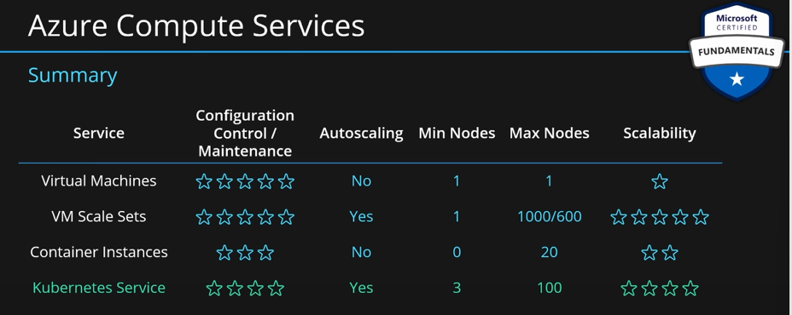

**Configuration control and maintenance is high because AKS allows very customization containers. Also, you need good technical skills to manage them, hence maintenance is also high.**

**Use containers in your solutions:**

Containers are often used to create solutions by using **a microservice architecture**. This architecture is where you break solutions into smaller, independent pieces. For example, you might split a website into a container hosting your front end, another hosting your back end, and a third for storage. This split allows you to separate portions of your app into logical sections that can be maintained, scaled, or updated independently.

Imagine your website back-end has reached capacity but the front end and storage aren't being stressed. With containers, you could scale the back end separately to improve performance. If something necessitated such a change, you could also choose to change the storage service or modify the front end without impacting any of the other components.

**App Service:** Main purpose of this service is to **build web applications**. Devs will create a simple **package** and that package will be deployed to **app service**. App service will deploy this package on multiple nodes and expose it to the users. This is a simple service compared to the previous ones we saw. No need to create any images or containers. Just send your code to the app service and you’re done.

It supports multiple programming languages and containers. You can create you web app in any language available in the market. If App service has support for it, you can deploy easily.

**Azure App Service**

App Service enables you to build and host web apps, background jobs, mobile back-ends, and RESTful APIs in the programming language of your choice without managing infrastructure. It offers automatic scaling and high availability. App Service supports Windows and Linux. It enables automated deployments from GitHub, Azure DevOps, or any Git repo to support a continuous deployment model.

Azure App Service is a robust hosting option that you can use to host your apps in Azure. Azure App Service lets you focus on building and maintaining your app, and Azure focuses on keeping the environment up and running.

Azure App Service is an **HTTP-based service** for hosting web applications, REST APIs, and mobile back ends. It supports multiple languages, including .NET, .NET Core, Java, Ruby, Node.js, PHP, or Python. It also supports both **Windows and Linux environments.**

**Types of app services:**

With App Service, you can host most common app service styles like:

* Web apps
* API apps
* WebJobs
* Mobile apps

App Service handles most of the infrastructure decisions you deal with in hosting web-accessible apps:

* Deployment and management are integrated into the platform.
* Endpoints can be secured.
* Sites can be scaled quickly to handle high traffic loads.
* The built-in load balancing and traffic manager provide high availability.

All of these app styles are hosted in the same infrastructure and share these benefits. This flexibility makes App Service the ideal choice to host web-oriented applications.

**Web apps:**

App Service includes full support for hosting web apps by using ASP.NET, ASP.NET Core, Java, Ruby, Node.js, PHP, or Python. You can choose either Windows or Linux as the host operating system.

**API apps:**

Much like hosting a website, you can build REST-based web APIs by using your choice of language and framework. You get full Swagger support and the ability to package and publish your API in Azure Marketplace. The produced apps can be consumed from any HTTP- or HTTPS-based client.

**WebJobs:**

You can use the WebJobs feature to run a program (.exe, Java, PHP, Python, or Node.js) or script (.cmd, .bat, PowerShell, or Bash) in the same context as a web app, API app, or mobile app. They can be scheduled or run by a trigger. WebJobs are often used to run background tasks as part of your application logic.

**Mobile apps:**

Use the Mobile Apps feature of App Service to quickly build a back end for iOS and Android apps. With just a few actions in the Azure portal, you can:

* Store mobile app data in a cloud-based SQL database.
* Authenticate customers against common social providers, such as MSA, Google, Twitter, and Facebook.
* Send push notifications.
* Execute custom back-end logic in C# or Node.js.

On the mobile app side, there's SDK support for native iOS and Android, Xamarin, and React native apps.

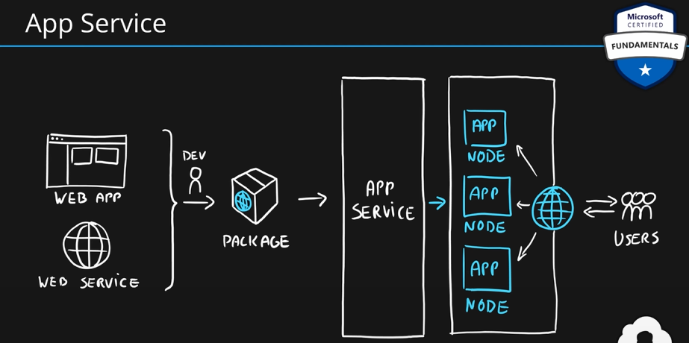

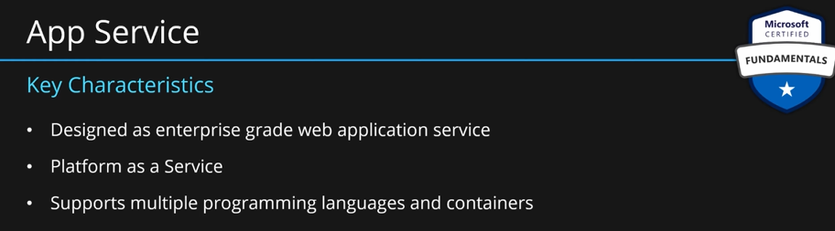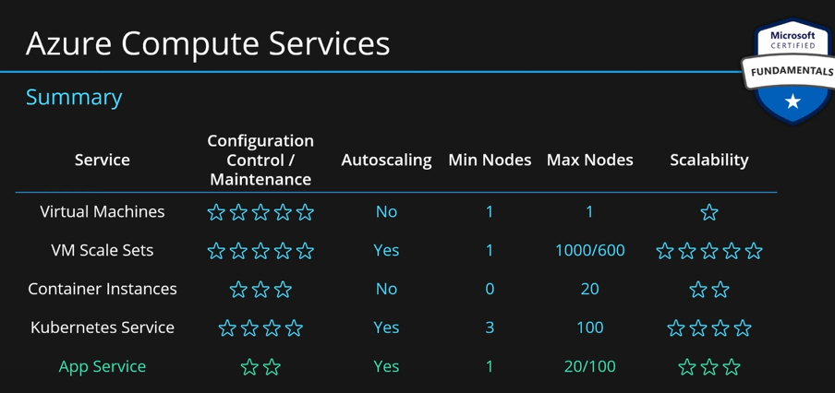

**Azure Functions/Function Apps:** If you want to deploy a piece of code instead of a full-fledged web app, then we can use this service. This service allows us to **deploy function/piece of code**. This is based on **app service.**

We will prepare a small package with the code. Then deploy it to function app. Function app will deploy to many nodes and make it available.

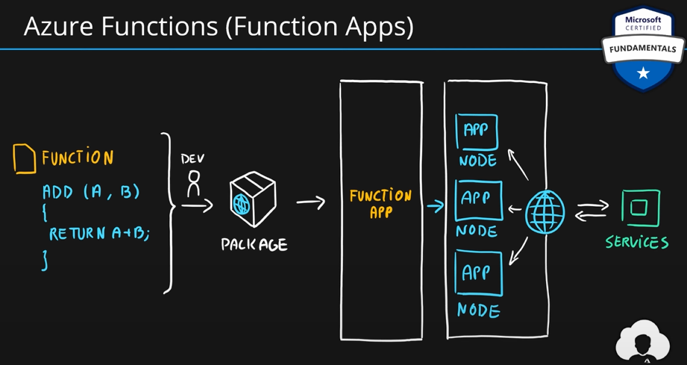

These are **PaaS** but very often are called **serverless**. Serverless means there is no dedicated server. If there is no traffic, then there are no charges. These are designed for **micro/nano services.** We should only use them for very simple functions.

**Benefits of Azure Functions**

Using Azure Functions is ideal when you’re only concerned about the code running your service and not about the underlying platform or infrastructure. Functions are commonly used when you need to perform work in response to an event (often via a REST request), timer, or message from another Azure service, and when that work can be completed quickly, within seconds or less.

Functions scale automatically based on demand, so they may be a good choice when demand is variable.

Azure Functions runs your code when it's triggered and automatically deallocates resources when the function is finished. In this model, you’re only charged for the CPU time used while your function runs.

Functions can be either stateless or stateful. When they're stateless (the default), they behave as if they're restarted every time they respond to an event. When they're stateful (called Durable Functions), a context is passed through the function to track prior activity.

Functions are a key component of serverless computing. They're also a general compute platform for running any type of code. If the needs of the developer's app change, you can deploy the project in an environment that isn't serverless. This flexibility allows you to manage scaling, run on virtual networks, and even completely isolate the functions.

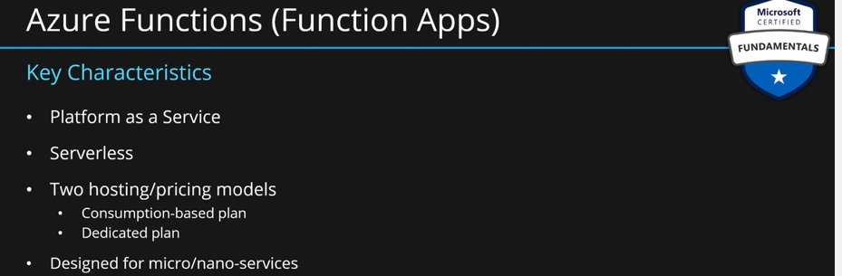

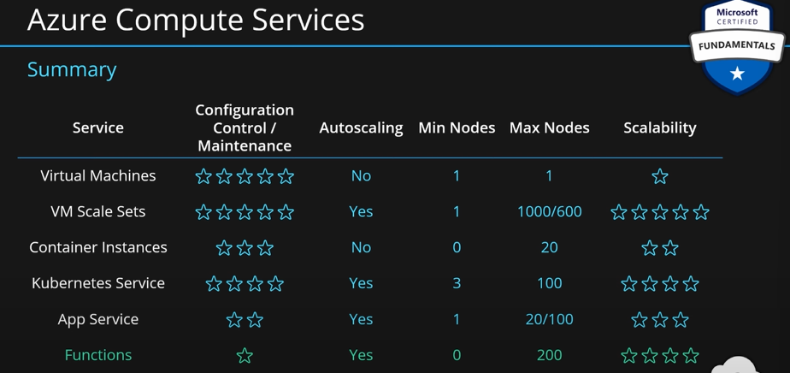

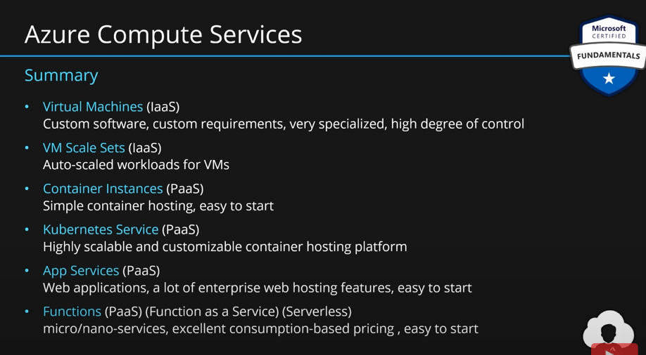

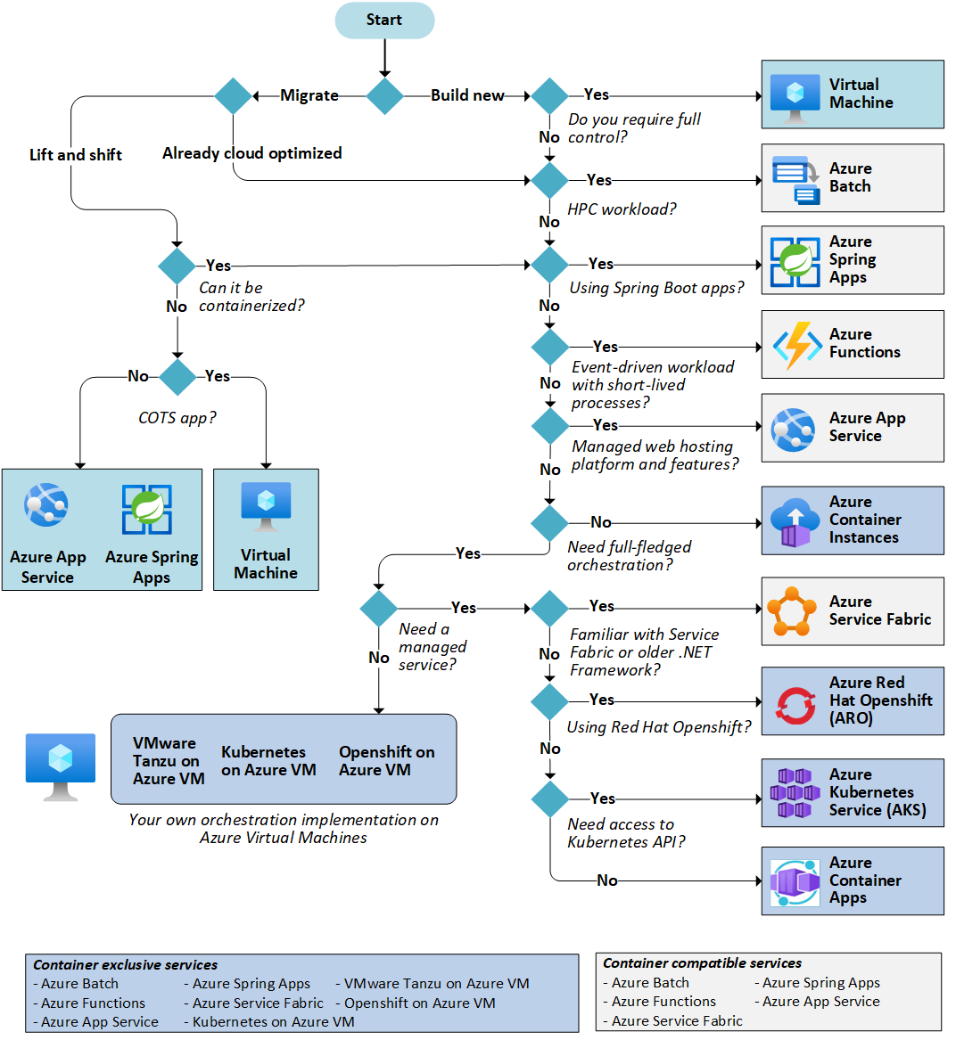

### Describe virtual networking, including the purpose of Azure virtual networks, Azure virtual subnets, peering, Azure DNS, Azure VPN Gateway, and ExpressRoute.

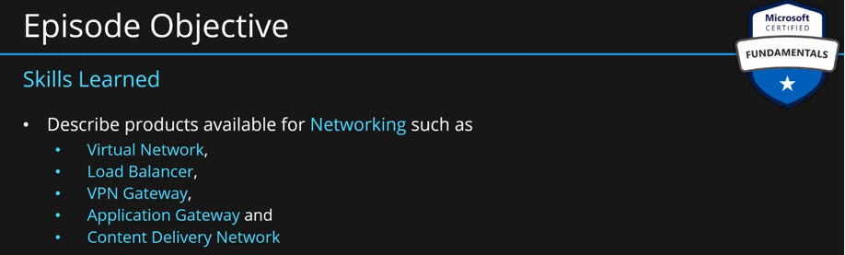

**Networking Services** are the type of services that allow customers to connect cloud and on-premises resources. They are also helpful in protecting and monitor services networking. They also help customers with application delivery.

**Azure Virtual Network (AVN):** Azure virtual networks and virtual subnets enable Azure resources, such as VMs, web apps, and databases, to communicate with each other, with users on the internet, and with your on-premises client computers. You can think of an Azure network as an extension of your on-premises network with resources that link other Azure resources.

let’s say you have two VMs in azure. VMs also need to be placed into representation of **physical networking infrastructure.** This representation is called **Azure Virtual Network (AVN).** Virtual networks allow users to create, monitor, manage and secure connectivity between azure resources and also between azure and on-premises environments.

Azure virtual networks provide the following key networking capabilities:

* Isolation and segmentation
* Internet communications
* Communicate between Azure resources
* Communicate with on-premises resources
* Route network traffic
* Filter network traffic
* Connect virtual networks

Azure virtual networking supports both public and private endpoints to enable communication between external or internal resources with other internal resources.

* **Public endpoints have a public IP address and can be accessed from anywhere in the world.**
* **Private endpoints exist within a virtual network and have a private IP address from within the address space of that virtual network.**

Virtual networks can be segmented into smaller pieces called subnets. There are two purposes of subnets:

* Help users manage their IP address allocation in a more efficient manner.
* To group related resources together. This helps in applying filters and security rules across multiple resources within the same subnet. Eg. by grouping all the resources hosting your web applications and only allowing web traffic to go into that subnet.

**Isolation and segmentation:**

Azure virtual network allows you to create multiple isolated virtual networks. When you set up a virtual network, you define a private IP address space by using either public or private IP address ranges. The IP range only exists within the virtual network and isn't internet routable. You can divide that IP address space into subnets and allocate part of the defined address space to each named subnet.

For name resolution, you can use the name resolution service that's built into Azure. You also can configure the virtual network to use either an internal or an external DNS server.

**Internet communications**

You can enable incoming connections from the internet by assigning a public IP address to an Azure resource or putting the resource behind a public load balancer.

**Communicate between Azure resources:**

You'll want to enable Azure resources to communicate securely with each other. You can do that in one of two ways:

Virtual networks can connect not only VMs but other Azure resources, such as the App Service Environment for Power Apps, Azure Kubernetes Service, and Azure virtual machine scale sets.

Service endpoints can connect to other Azure resource types, such as Azure SQL databases and storage accounts. This approach enables you to link multiple Azure resources to virtual networks to improve security and provide optimal routing between resources.

**Communicate with on-premises resources:**

Azure virtual networks enable you to link resources together in your on-premises environment and within your Azure subscription. In effect, you can create a network that spans both your local and cloud environments. There are three mechanisms for you to achieve this connectivity:

* **Point-to-site virtual private network** connections are from a computer outside your organization back into your corporate network. In this case, the client computer initiates an encrypted VPN connection to connect to the Azure virtual network.
* **Site-to-site virtual private networks** link your on-premises VPN device or gateway to the Azure VPN gateway in a virtual network. In effect, the devices in Azure can appear as being on the local network. The connection is encrypted and works over the internet.
* **Azure ExpressRoute** provides a dedicated private connectivity to Azure that doesn't travel over the internet. ExpressRoute is useful for environments where you need greater bandwidth and even higher levels of security.

**Route network traffic:**

By default, Azure routes traffic between subnets on any connected virtual networks, on-premises networks, and the internet. You also can control routing and override those settings, as follows:

* Route tables allow you to define rules about how traffic should be directed. You can create custom route tables that control how packets are routed between subnets.
* Border Gateway Protocol (BGP) works with Azure VPN gateways, Azure Route Server, or Azure ExpressRoute to propagate on-premises BGP routes to Azure virtual networks.

**Filter network traffic:**

Azure virtual networks enable you to filter traffic between subnets by using the following approaches:

* **Network security groups** are Azure resources that can contain multiple inbound and outbound security rules. You can define these rules to allow or block traffic, based on factors such as source and destination IP address, port, and protocol.
* **Network virtual appliances** are specialized VMs that can be compared to a hardened network appliance. A network virtual appliance carries out a particular network function, such as running a firewall or performing wide area network (WAN) optimization.

**Connect virtual networks:**

You can link virtual networks together by using virtual network peering. Peering allows two virtual networks to connect directly to each other. Network traffic between peered networks is private, and travels on the Microsoft backbone network, never entering the public internet. Peering enables resources in each virtual network to communicate with each other. These virtual networks can be in separate regions, which allows you to create a global interconnected network through Azure.

**User-defined routes (UDR)** allow you to control the routing tables between subnets within a virtual network or between virtual networks. This allows for greater control over network traffic flow.

As a user, you have complete freedom to create and manage subnets and virtual networks.

There are many reasons and technical limitations because of which you will need many virtual networks. They are:

**Virtual networks** can only resides within a **single region** and **a virtual network** can only have resources from that region only. So, if you are building **a multi-region application** then you will end up with multiple **virtual networks**. Now, if you want to connect multiple virtual networks either you can use **VNET peering**, this allows you to combine virtual networks together and allow them to act as one or you can use **VPN gateway**.

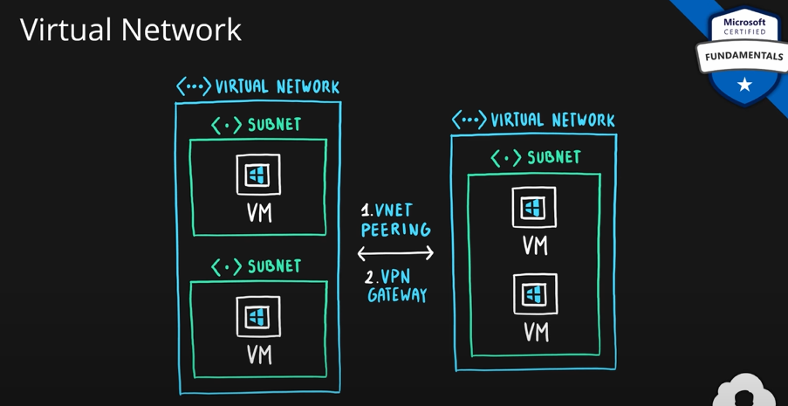

**Key Points:**

* **Azure Virtual Networks are emulation of physical networking infrastructure**. Just like VMs are emulation of physical hardware.
* They are designed for **isolation, segmentation, communication, filtering, routing** between resources (internet and on-premises)
* Azure Virtual Network is scoped to a **single region**.
* Virtual networks can communicate with each other using **VNet Peeing or VPN Gateway.**
* They can be segmented into one or more **subnets**.

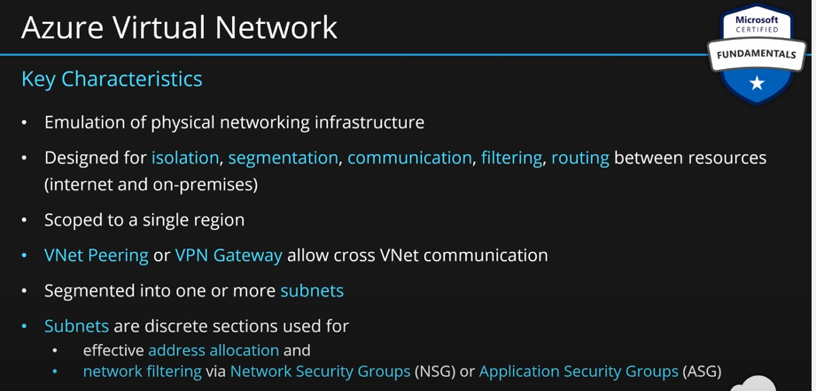

When you create a VM, it is assigned a virtual network by default. You can go to the VM and go to monitoring and then go to diagram. This diagram shows the structure of your VM. **Az**-**900**-**vm**-**net** is the name of the **virtual network**. This has a **default** **subnet**. There is a network interface **amdemo**-**vm119.**

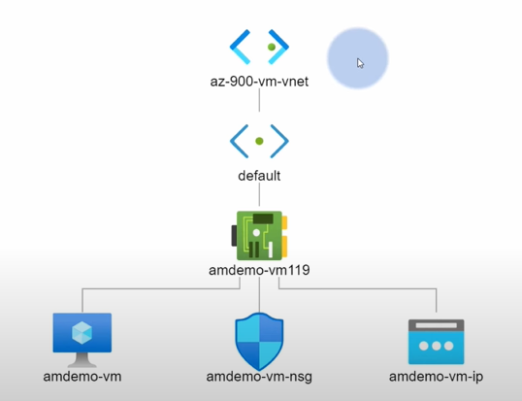

**Virtual Network Gateway of VPN Gateway:** These are used to connect on-premises environments to virtual networks and vice versa. The communication happens over public internet, but the communication is entirely encrypted. VPN gateways can also be used to connect virtual networks, but this is less common case.

A **virtual private network (VPN)** uses an encrypted tunnel within another network. VPNs are typically deployed to connect two or more trusted private networks to one another over an untrusted network (typically the public internet). Traffic is encrypted while traveling over the untrusted network to prevent eavesdropping or other attacks. VPNs can enable networks to safely and securely share sensitive information.

So, use VPN gateways whenever you need to connect on-premises environments to azure over public internet. Or, if you need to have cross-regional communication of azure virtual networks.

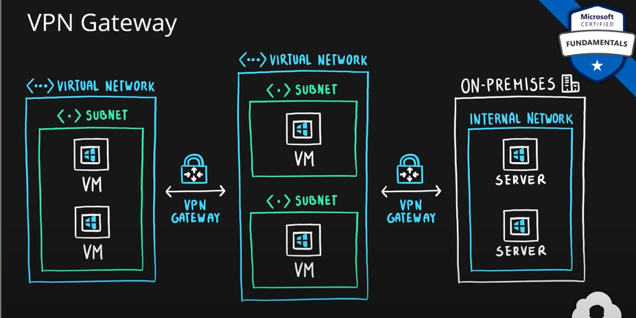

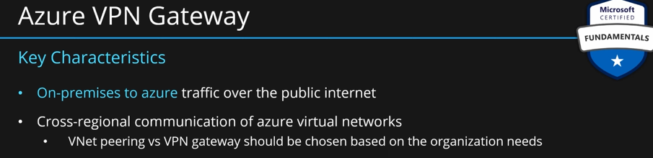]

**VPN gateways:**

A VPN gateway is a type of virtual network gateway. Azure VPN Gateway instances are deployed in a dedicated subnet of the virtual network and enable the following connectivity:

* Connect on-premises datacenters to virtual networks through a site-to-site connection.
* Connect individual devices to virtual networks through a point-to-site connection.
* Connect virtual networks to other virtual networks through a network-to-network connection.

All data transfer is encrypted inside a private tunnel as it crosses the internet. You can deploy only one VPN gateway in each virtual network. However, you can use one gateway to connect to multiple locations, which includes other virtual networks or on-premises datacenters.

When setting up a VPN gateway, you must specify the type of VPN - either policy-based or route-based. The primary distinction between these two types is how they determine which traffic needs encryption. In Azure, regardless of the VPN type, the method of authentication employed is a pre-shared key.

**Policy-based VPN gateways** specify statically the IP address of packets that should be encrypted through each tunnel. This type of device evaluates every data packet against those sets of IP addresses to choose the tunnel where that packet is going to be sent through.

**In Route-based gateways,** IPSec tunnels are modeled as a network interface or virtual tunnel interface. IP routing (either static routes or dynamic routing protocols) decides which one of these tunnel interfaces to use when sending each packet. Route-based VPNs are the preferred connection method for on-premises devices. They're more resilient to topology changes such as the creation of new subnets.

**Use a route-based VPN gateway if you need any of the following types of connectivity:**

* Connections between virtual networks
* Point-to-site connections
* Multisite connections
* Coexistence with an Azure ExpressRoute gateway

**High-availability scenarios:**

If you’re configuring a VPN to keep your information safe, you also want to be sure that it’s a highly available and fault tolerant VPN configuration. There are a few ways to maximize the resiliency of your VPN gateway.

**Active/standby**

By default, VPN gateways are deployed as two instances in an active/standby configuration, even if you only see one VPN gateway resource in Azure. When planned maintenance or unplanned disruption affects the active instance, the standby instance automatically assumes responsibility for connections without any user intervention. Connections are interrupted during this failover, but they're typically restored within a few seconds for planned maintenance and within 90 seconds for unplanned disruptions.

**Active/active**

With the introduction of support for the BGP routing protocol, you can also deploy VPN gateways in an active/active configuration. In this configuration, you assign a unique public IP address to each instance. You then create separate tunnels from the on-premises device to each IP address. You can extend the high availability by deploying an additional VPN device on-premises.

**ExpressRoute failover**

Another high-availability option is to configure a VPN gateway as a secure failover path for ExpressRoute connections. ExpressRoute circuits have resiliency built in. However, they aren't immune to physical problems that affect the cables delivering connectivity or outages that affect the complete ExpressRoute location. In high-availability scenarios, where there's risk associated with an outage of an ExpressRoute circuit, you can also provision a VPN gateway that uses the internet as an alternative method of connectivity. In this way, you can ensure there's always a connection to the virtual networks.

**Zone-redundant gateways**

In regions that support availability zones, VPN gateways and ExpressRoute gateways can be deployed in a zone-redundant configuration. This configuration brings resiliency, scalability, and higher availability to virtual network gateways. Deploying gateways in Azure availability zones physically and logically separates gateways within a region while protecting your on-premises network connectivity to Azure from zone-level failures. These gateways require different gateway stock keeping units (SKUs) and use Standard public IP addresses instead of Basic public IP addresses.

**Describe Azure ExpressRoute:**

Azure ExpressRoute lets you **extend your on-premises networks into the Microsoft cloud over a private connection**, with the help of a connectivity provider. This connection is called an **ExpressRoute Circuit**. With ExpressRoute, you can establish connections to Microsoft cloud services, such as Microsoft Azure and Microsoft 365. This allows you to connect offices, datacenters, or other facilities to the Microsoft cloud. **Each location would have its own ExpressRoute circuit.**

Connectivity can be from an any-to-any (IP VPN) network, a point-to-point Ethernet network, or a virtual cross-connection through a connectivity provider at a colocation facility. **ExpressRoute connections don't go over the public Internet.** This allows ExpressRoute connections to offer more reliability, faster speeds, consistent latencies, and higher security than typical connections over the Internet.

**Features and benefits of ExpressRoute**

There are several benefits to using ExpressRoute as the connection service between Azure and on-premises networks.

* Connectivity to Microsoft cloud services across all regions in the geopolitical region.
* Global connectivity to Microsoft services across all regions with the ExpressRoute Global Reach.
* Dynamic routing between your network and Microsoft via Border Gateway Protocol (BGP).
* Built-in redundancy in every peering location for higher reliability.

**Connectivity to Microsoft cloud services**

ExpressRoute enables direct access to the following services in all regions:

* Microsoft Office 365
* Microsoft Dynamics 365
* Azure compute services, such as Azure Virtual Machines
* Azure cloud services, such as Azure Cosmos DB and Azure Storage

**Global connectivity:**

You can enable ExpressRoute Global Reach to exchange data across your on-premises sites by connecting your ExpressRoute circuits. For example, say you had an office in Asia and a datacenter in Europe, both with ExpressRoute circuits connecting them to the Microsoft network. You could use ExpressRoute Global Reach to connect those two facilities, allowing them to communicate without transferring data over the public internet.

**Dynamic routing:**

ExpressRoute uses the BGP. BGP is used to exchange routes between on-premises networks and resources running in Azure. This protocol enables dynamic routing between your on-premises network and services running in the Microsoft cloud.

**Built-in redundancy:**

Each connectivity provider uses redundant devices to ensure that connections established with Microsoft are highly available. You can configure multiple circuits to complement this feature.

**ExpressRoute connectivity models:**

ExpressRoute supports four models that you can use to connect your on-premises network to the Microsoft cloud:

* CloudExchange colocation
* Point-to-point Ethernet connection
* Any-to-any connection
* Directly from ExpressRoute sites

**Co-location at a cloud exchange**

Co-location refers to your datacenter, office, or other facility being physically co-located at a cloud exchange, such as an ISP. If your facility is co-located at a cloud exchange, you can request a virtual cross-connect to the Microsoft cloud.

**Point-to-point Ethernet connection**

Point-to-point ethernet connection refers to using a point-to-point connection to connect your facility to the Microsoft cloud.

**Any-to-any networks**

With any-to-any connectivity, you can integrate your wide area network (WAN) with Azure by providing connections to your offices and datacenters. Azure integrates with your WAN connection to provide a connection like you would have between your datacenter and any branch offices.

**Directly from ExpressRoute sites**

You can connect directly into the Microsoft's global network at a peering location strategically distributed across the world. ExpressRoute Direct provides dual 100 Gbps or 10-Gbps connectivity, which supports Active/Active connectivity at scale.

**Security considerations:**

With ExpressRoute, your data doesn't travel over the public internet, so it's not exposed to the potential risks associated with internet communications. ExpressRoute is a private connection from your on-premises infrastructure to your Azure infrastructure. Even if you have an **ExpressRoute connection, DNS queries, certificate revocation list checking, and Azure Content Delivery Network requests are still sent over the public internet.**

**Describe Azure DNS:**

Azure DNS is a hosting service for DNS domains that provides name resolution by using Microsoft Azure infrastructure. By hosting your domains in Azure, you can manage your DNS records using the same credentials, APIs, tools, and billing as your other Azure services.

Benefits of Azure DNS

Azure DNS leverages the scope and scale of Microsoft Azure to provide numerous benefits, including:

* Reliability and performance
* Security
* Ease of Use
* Customizable virtual networks
* Alias records

**Reliability and performance**

DNS domains in Azure DNS are hosted on Azure's global network of DNS name servers, providing resiliency and high availability. Azure DNS uses anycast networking, so each DNS query is answered by the closest available DNS server to provide fast performance and high availability for your domain.

**Security**

Azure DNS is based on Azure Resource Manager, which provides features such as:

* Azure role-based access control (Azure RBAC) to control who has access to specific actions for your organization.
* Activity logs to monitor how a user in your organization modified a resource or to find an error when troubleshooting.
* Resource locking to lock a subscription, resource group, or resource. Locking prevents other users in your organization from accidentally deleting or modifying critical resources.

**Ease of use**

Azure DNS can manage DNS records for your Azure services and provide DNS for your external resources as well. Azure DNS is integrated in the Azure portal and uses the same credentials, support contract, and billing as your other Azure services.

Because Azure DNS is running on Azure, it means you can manage your domains and records with the Azure portal, Azure PowerShell cmdlets, and the cross-platform Azure CLI. Applications that require automated DNS management can integrate with the service by using the REST API and SDKs.

**Customizable virtual networks with private domains**

Azure DNS also supports private DNS domains. This feature allows you to use your own custom domain names in your private virtual networks, rather than being stuck with the Azure-provided names.

**Alias records**

Azure DNS also supports alias record sets. You can use an alias record set to refer to an Azure resource, such as an Azure public IP address, an Azure Traffic Manager profile, or an Azure Content Delivery Network (CDN) endpoint. If the IP address of the underlying resource changes, the alias record set seamlessly updates itself during DNS resolution. The alias record set points to the service instance, and the service instance is associated with an IP address.

**Important**

**You can't use Azure DNS to buy a domain name. For an annual fee, you can buy a domain name by using App Service domains or a third-party domain name registrar. Once purchased, your domains can be hosted in Azure DNS for record management.**

### Define public and private endpoints.

Azure public and private endpoints provide secure connectivity from an on-premises network to an Azure service. A public endpoint is a fully qualified domain name that you can use to access your Azure account. A private endpoint provides secure connectivity when you connect to an on-premises network through a VPN tunnel, such as DirectAccess or Site-to-Site VPN.

**What are public and private endpoints?**

Public and private endpoints are critical to understanding how to connect your on-premises network with Azure. A public endpoint is a fully qualified domain name (FQDN) that you can use for all of your web applications and services, including those in the cloud. Private endpoints provide secure connectivity from an on-premises network to an Azure service, such as when you create a virtual machine or container VM (VM). The private IP address of each endpoint is unique within the scope of its own VNet.

Private endpoints are used by organizations who have multiple sites around the world where they need different levels of connectivity depending on which location they’re using at any given moment. For example, if someone in Sweden needs access while traveling through London but doesn’t want their data synced back home – then they’ll use a private virtual network instead!

**Need for private endpoints:**

If you’re building a cloud-hosted application, you may need to access your data from on-premises servers. This is where the need for private endpoints comes in.

Private endpoints are used for secure connectivity from an on-premises network to an Azure service. They provide protection against intruders who may be able to intercept data as it flows through the Internet or between two networks—and they also help ensure that your applications can only be accessed by authorized users who should have access rights over that data.

Private endpoints are typically used when building hybrid applications because they enable communication between virtual machines (VMs) running in different clouds: In this case, there must exist a gateway or load balancer that allows traffic between VMs using different protocols (for example HTTP vs HTTPS).

**How to use public and private endpoints**

There are two types of Azure endpoints: **public and private**. **A public endpoint is accessible to all users in a given subscription, whereas a private endpoint can only be used by members of a single organization (or tenant).**

When you create an Azure SQL database or table, the first thing that happens is that the server creates an endpoint for use with each database or table. Public endpoints work just like any other type of website—they’re hosted on Microsoft’s servers and have access control features like quotas, authentication methods and custom headers. Private endpoints are similar, but they don’t have these same features; instead they’re kept inside your own cloud infrastructure so that only authorized users can access them.

**Next steps**

Now that you know how to create an Azure endpoint and connect it to your database, let’s look at how to set up a public endpoint. This is important because the data should be public by default.

Public endpoints provide access to all users in your subscription, including those who don’t have an active subscription or don’t have permissions on their account (for example, when they join a team). There are two main ways of setting up a public endpoint:

Set up an authentication mechanism for accessing the service using Microsoft Graph APIs (via OAuth2). You’ll need this if you want users from other subscriptions or organizations outside of yours who aren’t necessarily logged into any Azure accounts yet still want access through your app/service;

Use API keys in place of authentication mechanisms such as tokens or credentials.(You can find more information about API keys here )

Azure public endpoint is a fully qualified domain name. Azure private endpoint provides secure connectivity from an on-premises network to an Azure service.

Azure public endpoint names start with the letter ‘a’ and are used for all services in the cloud (including Azure SQL databases).

Conclusion

This is a good time to summarize, and then move on to the next steps in this article. We’re going to take a few moments now to summarize what we discussed in this post, so that you can make sure everything is clear in your mind before moving on with the rest of Azure Security Center!